# Simulating improvements on mining compressed air systems

B.M. Friedenstein 28354516

Dissertation submitted in fulfilment of the requirements for the degree *Magister* in Electrical and Electronic Engineering at the Potchefstroom Campus of the North-West University

Supervisor: Dr Johann van Rensburg

September, 2017

NORTH-WEST UNIVERSITY ®

#### It all starts here TM

YUNIBESITI YA BOKONE-BOPHIRIMA NOORWES-UNIVERITEIT

**Abstract**

**Title:** Simulating improvements on mining compressed air systems

**Author:** B.M. Friedenstein

**Supervisor:** Dr Johann van Rensburg

**School:** North-West University Potchefstroom Campus

**Degree:** Masters in Electrical and Electronic Engineering

As operational costs of deep level mines increases and gold ore grades decrease, profitability in the gold mining sector is becoming a challenge. Electricity tariff increases have contributed to a rise in the cost of operating mines. Compressed air systems are utilised on mines as they provide safe, reliable power for various underground machines. Compressed air is also used for emergency oxygen in refuge bays.

Compressed air systems utilise a significant portion of a mine’s total energy. It has been shown that many deep level mine compressed air networks have inefficiencies. Improving the efficiency of these systems could result in a reduction of operational costs by reducing the energy required to produce compressed air. Additionally, an improvement in service delivery could be achieved.

Previous studies have shown the usefulness of simulations to develop improvements for deep level mining systems. However, these studies have not followed a structured methodology for developing compressed air simulation for deep level mines. Previous studies have also simplified compressed air models reducing the simulation precision and testable scenarios.

In this study a simulation methodology was therefore developed. Investigations into the compressed air systems are performed. A model is then developed in software to accurately recreate the system operation. Finally a proposed means of improvement is simulated, analysed and quantified in terms of improvements in energy savings and service delivery.

Two case studies were evaluated. For each case study a variety of scenarios were simulated. In case study A by reducing air used by refuge bays in simulation, a reduction of 1 MW E.E. would be achieved with addition to a significant improvement of 18 kPa to system pressure.

Drop tests implemented on the case studies validated the simulation with a precision of 5%.

The study showed that simulation is a important tool for identification improvements in large compressed air systems. By utilising a structured methodology to develop detailed compressed air simulations, inefficiencies and operational improvements were identified.

**Keywords:** Mining, Energy, Compressed air, modelling, Simulation, operational im- provements

*Simulating improvements on mining compressed air systems* ii

## Acknowledgements

Contents

Abstract i

Acknowledgements iii

Abbreviations and nomenclature vi

List of figures and tables viii

1. Introduction and background 1

1.1 Preamble . . . . . . . . . . . . . . . . . . . . . . . . . . . . . . . . . . . . . 2

* 1. Background on deep level mining . . . . . . . . . . . . . . . . . . . . . . . . 2
  2. Compressed air systems in mining . . . . . . . . . . . . . . . . . . . . . . . . 4

1.4 Use of simulation in industry . . . . . . . . . . . . . . . . . . . . . . . . . . 5

1.5 Problem statement and objectives . . . . . . . . . . . . . . . . . . . . . . . . 6

1.6 Dissertation overview . . . . . . . . . . . . . . . . . . . . . . . . . . . . . . . 7

1. Overview of simulation and compressed air applications 8

2.1 Introduction . . . . . . . . . . . . . . . . . . . . . . . . . . . . . . . . . . . . 9

* 1. Background on mining compressed air networks . . . . . . . . . . . . . . . . 9
  2. Review of compressed air energy interventions in industry 13
  3. Use of simulations to identify improvements in mining systems 17
  4. Use of simulation in mining compressed air optimisation 27
  5. Conclusion 32

1. Developing a simulation methodology 34
   1. Introduction 35
   2. Investigate the system 35
   3. Develop and verify a simulation model 37
   4. Implement the simulation 47
   5. Conclusion 49
2. Results and validation 51
   1. Introduction 52
   2. Case study 1. Simulated improvements on mine A 52
   3. Case study 2: Simulated improvements on mine B 60
   4. Case study 3: Periodic simulation analysis 71
   5. Potential benefit for SA mines 74
   6. Conclusion 75
3. Conclusion 76
   1. Preamble 77
   2. Dissertation overview 77
   3. Limits of this study 78
   4. Recommendations for future studies 78

Bibliography 78

Appendix I Simulation process flow schematics 85

Appendix II Model components verification tables 93

Appendix III Detailed mining level investigation diagrams 97

## Acronyms

CALDS Compressed Air Leakage Documentation System COLS Corrected Ordinary Least Square

DCS Dynamic Compressor Selection DSM Demand Side Management

E.E. Energy efficiency MAE Mean Absolute Error MSE Mean Square Error

p.a Per annum

P.C. Peak-clip

PGM Platinum group metal PI Proportional-Integral

PLC Programmable logic controller PTB Process Toolbox

RMSE Root Mean Square Error

SCADA Supervisory control and data acquisition SI International System of Units

SP Set-Point

THS Thermal-hydraulic simulation TOU Time Of Use

VFD Variable Frequency Drive VSD Variable Speed Drive

## Nomenclature

Celcius The SI measure for tempature *C*

Correlation coefficient The statistical measure of linear relationship between two vari- r ables

kilopascals The international measure of pressure *kPa*

polytropic

coefficient The thermodynamic coeificient used when describing the heat — transfer due to compression or expansion

Stopes mining area -

Tonne The non-SI measure for 1000 kilograms *T*

Watt The SI measure of power *W*

# List of Figures

* 1. Electricity price increases between 2007 and 2017 compared to the inflation

rate in South Africa.. . . . . . . . . . . . . . . . . . . . . . . . . . . . . . . . 2

* 1. A layout showing the mining processes. . . . . . . . . . . . . . . . . . . . . . 3
  2. The energy consumption for each mining system. . . . . . . . . . . . . . . . 4
  3. A scematic of a multistage centrifugal compressor. 10
  4. An example of compressed air inlet in an underground refuge bay chamber of

a mine. 11

* 1. A typical operation schedule of a deep level mine. 12
  2. The leakage flow as a function of inlet pressure and leakage area 15
  3. The Compressed air energy and flow consumed per T of ore produced. 17
  4. Energy benchmark model for a mining compressed air system 19
  5. Example of simulation error calculations. 25
  6. Simplified compressed air netowrk model. 27
  7. Simplified system model. 29
  8. Compressor relocation simulation model. 30
  9. Simplified compressed air ring model. 31
  10. Simulation model for a complex air network. 31
  11. Flow diagram of the methodology for this study 35
  12. Selecting boundaries for the simulation model. 38
  13. Interpolating input data to increase time-step resolution. 39
  14. Average summer ambient air conditions at a South African gold mine. 40
  15. Estimating the characteristic curve of a compressor by fitting a quadratic function to points of operation. 41
  16. Integrating the compressor component into the simulation. 41
  17. Implementing flow demands and leaks into the simulation. 42
  18. Control components in Process toolbox 43
  19. Modelling the compressor control from a guide vain 43
  20. An example of a compressed air control valve 44
  21. An example of two baseline periods, showing a changed compressor schedule. 46
  22. The periodic simulation process that was followed in this analysis. 47
  23. An example of a baseline vs. optimised power comparison. 48
  24. Eskom’s weekday TOU tariff structure. 48
  25. Simplified process flow chart of the compressed air network. 53
  26. Average power profile 54
  27. The simulated power compared to the actual measurement 56
  28. The simulated flow compared to the actual measurement 57
  29. The simulated Pressure compared to the actual measurement 57
  30. Energy savings by reducing compressor set-points 58
  31. Power savings 58
  32. Actual power savings achieved on the system 59
  33. Process schematic of the compressed air network. 61
  34. Comparing the pressure response of simulation to the actual measured pressure 63
  35. Verification of the total (a) flow and (b) power of the system using the actual pressure profile. 64
  36. Verifying the Pressure response of the system given the pressure set points as inputs 65
  37. The Baseline system power compared to the system power when refuge bay

leaks are reduced 66

* 1. The Baseline system pressure compared to the system pressure when refuge

bay leaks are reduce. 66

* 1. Underground level layout. 68
  2. Flow reduction during blasting period for 105 level 69
  3. Comparing simulated flow interventions on 105L. 69
  4. Energy saving achieved by general peak time Station control 70
  5. The flow, pressure and power error percentages for daily periodic simulations

over a month. 72

* 1. Supply efficiency and Compressor 1’s average power output over the time of

the periodic analysis. 73

* 1. Comparison using alternative power source. 73
  2. Gold and PGM mines in South Africa 74
  3. Mine A: Simulation process flow schematic 86
  4. Mine B: Baseline process flow schematic 87
  5. Mine B: Compressors 88
  6. Mine B: surface compressed air users 88
  7. Mine B: Main shaft compressed air users 89
  8. Mine B: Sub-shaft compressed air users 90
  9. Mine B: Simulation process Flow diagrams for the refuge bay scenario. 91
  10. Mine B: Simulation process Flow diagram for the station isolation stope control. 92

III.1 Underground mining level layout. 98

# List of Tables

* 1. Results of the comparison of verification methods. 25
  2. Simulation verification methods that were implemented in previous studies. . 26
  3. Summary of energy saving estimation rules 28
  4. Air pipe component model parameters. 39
  5. The input parameters for the after-cooling simulation model 44
  6. Data inputs and outputs for the Case study 1 simulation model 55
  7. Case study 1: Verification of simulation model. 56
  8. Comparison of Mine A’s simulated scenarios 59
  9. Simulation inputs and outputs 62
  10. Verification of simulation model. 63
  11. Comparison of the simulated scenarios 70
  12. Data inputs and outputs for the simulation 71
  13. Case study A: Model verification 94
  14. Case study A: Model verification continued 95
  15. Case study B: Model verification 96

## CHAPTER 1

**Introduction and background**

‘*Precisely one of the most gratifying results of intellectual evolution is the continuous opening up of new and greater prospects.*’ - Nikola Tesla

## Preamble

This chapter firstly discusses background regarding deep level mining in South Africa. Next, the need to reduce costs of operation in the mining sector is examined. From this a focus in reducing energy consumption of compressed air systems is developed. Next, background on compressed air operation and energy interventions are discussed. Simulations and their value in industry is discussed leading to a problem statement and objectives of the study. Finally, an overview for the dissertation is provided.

## Background on deep level mining

### Mining profitability

Various technical, economic, social and operational challenges are posing a risk to the prof- itability of the South African mining sector. One of the challenges the sector faces is a rise in the cost of operation [1].

A considerable factor that is contributing to the rise of operational costs in South African gold mines has been the increase in electricity costs. As shown in fig. 1.1, the general cost of electricity has increased at a rate greater than inflation since 2008 [2].

40

35

30

25

20

15

10

5

0

2008

% increase

31.3

27.5

24.8

25.8

16.0

9.35

8.0

8.0

8.0

6.04

6.41

5.71

8.0

7.07

8.0

6.2

3.37

2010

5.3

5.32 5.18

2012

Year

2014

2016

Eskom tariff increases (%) Inflation rate (%)

Figure 1.1: Electricity price increases between 2007 and 2017 [2] compared to the inflation rate in South Africa1.

In addition to rising electricity costs, gold ore grades of South African mines have fallen

1 inflation.eu, ”Historic inflation South Africa.” [Online] [http://www.inflation.eu/inflation-rates/](http://www.inflation.eu/inflation-rates/south-africa/historic-inflation/cpi-inflation-south-africa.aspx) [south-africa/historic-inflation/cpi-inflation-south-africa.aspx](http://www.inflation.eu/inflation-rates/south-africa/historic-inflation/cpi-inflation-south-africa.aspx), [Accessed 25 March 2017].

substantially over the last few decades [3]. As ore grades decline, the energy utilised per unit of metal increases exponentially [4]. Therefore, mines require significantly more energy per unit of metal produced. This combination of tariff increases and increased energy usage per unit have led to significant rises in mining operation costs.

### Process of a deep level mine

South Africa’s mines are some of the deepest in the world. Some mine shafts are reaching depths deeper than 4000*m* below the surface [5]. The process of extracting ore at this depth is dependent on the essential services, mainly cooling and ventilation, pumping, compressed air and hoisting, as shown in fig. 1.2.

Cooling and ventilation system are required to maintain a safe working temperature underground. Pumping is critical to remove service and fissure water, preventing flooding. Compressed air is needed to safely power underground drills and machines. Finally, hoisting systems are used to bring the ore to the surface and to transport mine workers in the mine.



BAC Tower

Processing plant

Fridge Plant

Compressors

PCT

Ventilation Fan

Surface

V-101

Level 1

Pump

Dam

Level 2

...

...

...

Pumping

Processing plant Hoisting Compressed air

Ventilation and cooling

Level N-2

Level N-1

Level N

Shaft

Dam

Pump

Figure 1.2: A layout showing the mining processes.

#### Energy usage of mining services

The mining industry uses extensive amounts of energy. In South Africa, the industry utilizes approximately 15% of the national electricity supplier’s yearly output, of which, gold and platinum mines use 80%.[6]

fig. 1.3 shows the division of energy within the mining industry. The chart shows that compressed air systems utilizes the most energy within a mining industry. It is reasoned that energy can be most effectively reduced through the implementation of energy interventions on compressed air systems.

25

20

15

10

5

0

Compressed Mining air processes

Ventilation Buildings Processing

and cooling

Pumping

and hostels

plant

Hoisting

Other

% of total energy consumption

Figure 1.3: The energy consumption for each mining system [7].

## Compressed air systems in mining

### Compressed air in operation

Largely due to their reliability, versatilely and ease of use, the South African mining industry has installed extensive compressed air networks. These systems can have compressors with capacities of up to 15 Megawatt (*MW)* [8]. However, the supply of compressed air is a highly energy demanding and costly process [9]. The energy used for compressed air production contributes to between 9% and 20% of the total mining energy consumption [6], [10].

Large compressed air systems are likely inefficient. Internationally, the expected energy savings potential of a large compressed air network is 15% [11]. Marais [12] showed that energy saving interventions can lead to energy and cost savings of up to 30% and 40%.

### Characteristic inefficiencies of compressed air systems

Compressed air distribution networks in the mining industry consist of multiple compressors and working areas up to eight kilometres away from the source [8]. Due to their size and complexity, these systems are prone to large energy losses.

Compressed air leakage accounts for as much as 35% of the energy losses of a compressed air network [13]. Other systemic losses include, faulty valves, pipe diameter fluctuations,

obstructed air compressor intake filters and inefficient compressors.

Leakage and inefficiency detection strategies are not often pursued in the South African mining industry [14]. Many mines do however perform leak inspections either internally or by a outside company. In these inspections, an ultrasonic detector is used to locate the leak. Alternatively, some mines employ the “walk and listen” method to identify leaks from the audible sound that it produces [14]. Once the inspection is completed, the findings, including the locations and estimated costs of all identified leaks, are reported.

### Compressed air savings interventions

Energy interventions to reduce energy on compressed air systems designed using the following strategies [15]:

* + - * Reduce leaks.
      * Reduce demand.
      * Reduce unauthorised usage.
      * Increase supply efficiency.
      * Optimise supply.

Often a combination of energy strategies will lead to the most savings [8]. In chapter 2, successfully compressed air interventions on mining systems we be discussed from literature.

Once an energy saving measure has been identified, it is most often necessary to make estimations to determine the potential costs and benefits of the intervention. This has usually been performed using first principle calculations, simplified mathematical models and practical tests if possible. However, new tools have enabled quick, accurate compressed air model development. Through simulations, accurate estimations can be obtained quickly, with no risk and at comparatively low resource requirement.

## Use of simulation in industry

### Background in industrial simulation

Continuous improvements in computing hardware has led to major advancement in software technology. Consequently, the use of computational simulation has become an increasingly valuable tool for many industries. [16]

In *Handbook of simulation: principles, methodology, advances, applications, and practice*, the advantages of the use of simulation in industry are discussed as follows [17]:

* + - * The ability to test new policies, operating procedures and methods without causing a disruption to the actual system.
      * The means to identify problems in complex systems by gathering insight in the inter- actions within the system.
      * The facility to compress or expand time to investigate phenomena thoroughly.
      * The capability to determine the limits and constraints within a system.
      * The potential to build consensus with regard to proposed designs or modifications.

### Simulation usage in compressed air optimisation

Simulation has been used to test and identify energy and operational improvements in mining compressed air systems. In the past producing complex models for mining systems was not feasible as simulation software required difficult to obtain data inputs [12]. This lead to simplified models that cannot provide accurate results and limited the types of scenarios that can be simulated.

However, the use of planned manual measurements, estimations and new software technolo- gies can overcome this challenge [18],[19]. This would allow for the development of more detailed and accurate mining compressed air simulations.

## Problem statement and objectives

### Problem statement

Rising costs and falling ore grades are driving the mining industry to reduce operational costs. The industry can save significant energy cost through interventions in compressed air systems. However, manual testing of these interventions are risky and cumbersome.

Computer modelling and simulation of compressed air systems can be used to quantify and priorities operational interventions with minimal risk. However, simulations have not been utilised to their full potential in compressed air systems. With new tools and more detailed simulation models, the energy and operation efficiency of mining compressed air systems can be improved, leading to significant energy and cost savings as well as other potential improvements for a mines operation.

### Research objectives

The main objective of this dissertation is to obtain energy savings through the identification of operational improvements in mining compressed air systems. A simulation process to will be developed to achieve this goal.

## 1.6 Dissertation overview

**Chapter 1** - This chapter serves as an introduction for the dissertation. The chapter provides the relevant background in mining, compressed air and simulation to establish the problem statement. The objectives of the study are then outlined.

**Chapter 2** - Chapter 2 provides a review of literature and necessary background relevant to the study. The chapter firstly provides background on mining compressed air networks. A review of compressed air energy interventions is then performed. This is followed by a review of simulation in industry and finally a review of simulation usgae in mining compressed air systems.

**Chapter 3** - Chapter 3 provides a simulation methodology. The methodology outlines the processes used to investigate a compressed air system, develop and calibrate simulation models and finally to implement simulations and obtain results.

**Chapter 4** - Chapter 4 provides validation of the methodology through case study results. Results of three case studies are provided. Finally the impact of large scale implementation of the simulation methodology is discussed.

**Chapter 5** - Chapter 4 concludes the dissertation. The chapter also provides recommend- dations for further studies regarding compressed air simulation.

## CHAPTER 2

**Overview of simulation and compressed air**

**applications**

‘*If I have seen further, it is by standing on the shoulders of giants.*’ - Isaac Newton

## Introduction

This chapter will firstly provide relevant background on the operation and subcomponents of compressed air networks. A review of literature regarding compressed air energy inter- ventions will then be performed. This review will summarise previous work to improve to improve the supply and demand efficiency of mining compressed air networks.

The use of simulation in mining systems will then be reviewed. This section will summarise the usage of mathematical estimation and simulations tools in the mining industry. From the literature available simulation tools as well as simulation and verification procedures will be discussed.

Finally simulation usage in compressed air systems will be discussed. The section will sum- marise the work, as well as the successes and shortfalls, that has already been performed with regard to simulation of large compressed air networks.

## Background on mining compressed air networks

### Preamble

Compressed air is used extensively in a mine in surface and underground operations. This section provides background regarding mining compressed air networks. The section firstly discusses the components that make up a mining compressed air system. The typical oper- ation of the system is then examined. Finally the instrumentation that is typically installed in compresssed air networks is discussed

### Compressor air network components

#### Compressors

Compressed air in mining is most commonly supplied by a centrifugal-type dynamic com- pressor [20],[21]. These machines achieve compression as a result of the centrifugal force from the high-speed rotation of impellers in the air. The rotating impeller is powered by a electric motor.

Multi-stage impeller compressor designs, as shown in fig. 2.11, are used to obtain higher pressure ratios [20]. The compression process is inefficient. Only about 5% to 10% of the

1 Abc oil refining, ”How centrifugal compressors operate” [Online] [http://abcoilrefining.blogspot.co.](http://abcoilrefining.blogspot.co.za/2012/03/how-centrifugal-compressors-operate.html) [za/2012/03/how-centrifugal-compressors-operate.html](http://abcoilrefining.blogspot.co.za/2012/03/how-centrifugal-compressors-operate.html), [Accessed 15 August 2017].

input energy of the process is converted into energy that is used [22].

Discharge

Suction

Figure 2.1: A schematic of a multi-stage centrifugal compressor1.

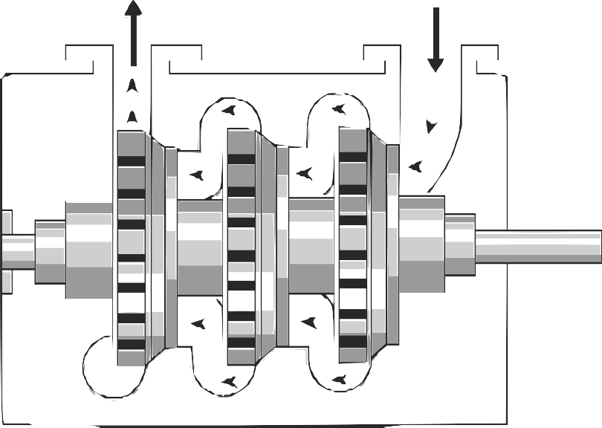

Rotor

Stage 3 Stage 2 Stage 1

#### Pneumatic rock drills

Drilling is mainly performed in the production areas or stopes of a mine. Drill machines are used to drill holes into the rock face. Once the holes have been drilled, explosives are then installed to break up the rock [23].

Compressed air is used to power pneumatic rock drills within a mine. Pneumatic rock drills run at an efficiency of 2%. This is low when compared to alternative rock drills such as electric, oil electro-hydraulic and hydro-powered drills that convert energy at an efficiency of between 20-31% [24], [14].

#### Refuge bays

Refuge bays are installed underground in deep level mines to provide safety to miners in the event of an emergency. Due safety regulations, most mines will utilise compressed air to deliver chilled air to the chamber [25]. fig. 2.2 shows an example of a compressed air inlet at an underground refuge bay. A muffler is installed to the end of the inlet air pipe to reduce noise.

The provision of 1.42 *l/s* of air per person at a pressure between 200 and 300 kilopascals is required to provide oxygen and prevent any poisonousness gas entering the refuge [25].

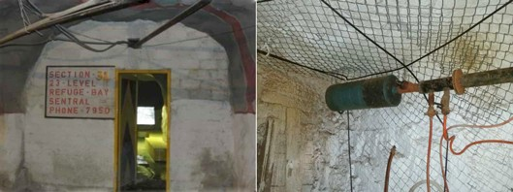

Figure 2.2: An example of compressed air inlet in an underground refuge bay chamber of a mine.

Airflow in the refuge bays are controlled by a manual valve within the chamber. The manual vales are often misused by mine workers in order to cool the bay through decompression of the air.

#### Processing plants

Processing plants are constructed near gold and mines. They are used when extracting metal from the ore that is obtained from the mining operation. These plants use compressed air for various systems, processes and equipment.

Processing plants often share compressed air network with mine to save costs[8]. The plants use relatively small amounts of air compared to mines. However, plant processes have pres- sure requirements that differ from the rest of the air network. If the plant air supply is not isolated from the shaft’s air system, energy optimisations can be complicated.

#### Other compressed air users

Due to the availability underground, compressed air is utilised for several other applications. These usages include, pneumatic loaders or rock shovels, pneumatic cylinders, dam sedi- ment agitation, cooling and ventilation and many other applications. This vast variety of applications also leads to misuse of compressed air. This leads to inefficient operation.

### Operation schedule

On a typical mine, various operations are scheduled different times of the day. Depending on the activity taking place, many mines will control the pressure to meet the requirements of the tasks [[26],8]. fig. 2.3 shows the schedule and pressure requirement on a typical deep

level mine.

As shown in fig. 2.3, the pressure requirement changes depending on the activity taking place. The drilling shift typically has the highest pressure requirement whilst blasting shift requires the lowest. Schedules and operation philosophies can differ between mines. Different operational schedules require alternative pressure requirement profiles.

Drilling

Blasting

560

540

520

500

480

460

440

420

400

Time of day Pressure requirement (kPa)

Pressure (kPa)

Sweeping and

cleaning

Workers travel to working areas

Explosive charge up

Sweeping and

cleaning

Figure 2.3: The typical operation schedule of a deep level mine [26].

00:00

01:00

02:00

03:00

04:00

05:00

06:00

07:00

08:00

09:00

10:00

11:00

12:00

13:00

14:00

15:00

16:00

17:00

18:00

19:00

20:00

21:00

22:00

23:00

### Instrumentation

For large industrial systems, thorough instrumentation is necessary to monitor performance and equipment conditions throughout the system. In a mining compressed air network, instrumentation is installed to monitor flows, pressures, temperatures and other process pa- rameters. Electrical instrumentation is also installed for sensing currents, power factors, voltages and power. Parameters that are often measured include valves input/output pres- sures and flows, valve and guide vain positions and air condition metrics are usually measured with instrumentation.

A Supervisory control and data acquisition (SCADA) system is used to monitor and con- trol processes throughout the mine. The instrumentation and SCADA are connected on a communication network. This communication between the underground Programmable logic controllers (PLCs) and surface SCADA is achieved using a substantial fibre optic netw[ork27]. The SCADA centralises instrumentation data from PLCs and instrumentation in the mine. The SCADA is also used to control machines and control instrumentation by transmitting control signals over the network.

### Summary

In this section various sub-components of compressed air networks were discussed. These sub-components included compressors, processing plants as well as underground air users. The daily process scheduling and the effect on compressed air requirements were then dis- cussed. Finally the typical instrumentation found in a mining compressed air system was summarised.

## Review of compressed air energy interventions in industry

### Preamble

Compressed air improvement can be obtained through intervention in either the supply or demand processes of a compressed air system [26]. Improvements in supply is achieved by increasing the efficiency of compressed air supply. Examples of these types of intervention include Dynamic Compressor Selection (DCS), compressor relocation, repairs and mainte- nance, etc.

Due to the size of mining compressed air networks, there is often a larger scope for improve- ment in air demand. Improving the demand is achieved by optimising air flow consumers, reducing leaks, etc.

This section will review compressed air supply and demand interventions that have im- proved energy or operation efficiency the mining industry. From the literature, successes and shortcomings in studies will be discussed and analysed with regard to this study.

### Strategies to improve compressed air supply

#### Optimising compressor control

Compressors types and numbers can differ widely from mining compressed air systems. Compressor selection is crucial in these systems to match the correct compressors with the requirements of the system [28].

In a study by Booysen [21] found that many mines control compressors using fixed target pressure points that are much higher than required. In one system, compressor controllers were set to target 650 *kPa* to ensure pressure underground did not fall below 500 *kPa*. Use

of high set-points can lead to excessive wasteful blow-off air flow when the pressure exceeds maximum points.

[29] showed through dynamic pressure set-point control1 and optimal compressor selection, energy savings can be achieved. In a case study, an average power reduction of 1.07 MW was achieved. The lead to an estimated energy cost saving of R3M.

Optimising control of compressors to match the demand of the system can be complicated. Variable Speed Drives (VSDs) and guide-vain are used to control the capacity of the system. More effective power reductions can be achieved through the use of VSD control. Running compressors at part load reduces efficiency. From literature, it has been shown electric motors will typical use 60-80% of there rated power when running at less than 50% load [30].

#### Reconfiguring compressed air networks

A number of old mining compressed air systems have not been adequately maintained and improved. Often they cannot sufficiently supply air to meet the demand or air is provided from non optimal sources. In a study by Bredenkamp [31], reconfiguring of the air network was investigated to improve these systems.

In the study, Bredenkamp investigated interconnecting the compressed air systems of two mining shafts and relocating of a compressor. This strategy lead to an average power reduc- tion of 1.7 MW and an estimated annual energy cost saving of R8.9M at the time.

### Strategies to reduce compressed air demand

Reducing the airflow demand is achieved by reducing air unnecessary airflow such as leaks, optimising the operating pressure to match the demand2 and by improving the efficiency of air usage or replacing equipment with non-pneumatic alternatives [15].

#### Leakage detection

Air leaks are a major inefficiency in mining compressed air systems. Improving leaks is relatively easier method to reduce air demand and improve the efficiency of the system [32]. Air leaks occur as a result of open pipes, fissure and breaks. Losses depend on the size of

1 Matching the supplied pressure with the specific required air demand.

2 This is achieved by identifying the minimum required operating pressure for all times of the day as illustrated in fig. 2.3

the leak and pressure in the network. fig. 2.4 shows the theoretical airflow of through a pipe orifice as a function of leakage area and pressure1. [32] showed that the system power consumption linearly increases with the amount of air leakage. Therefore, energy savings can be achieved through either reducing pressure or detecting and fixing leaks.

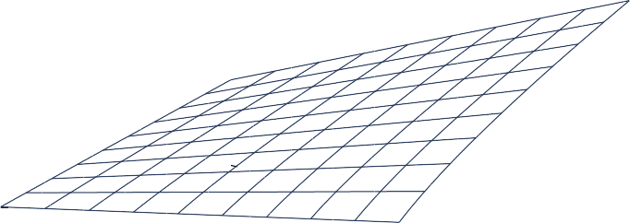

4*.*5

3

1*.*5

0

Flow (kg/s)

Figure 2.4: The leakage flow as a function of inlet pressure and leakage area3.

Leaks are often not easily detected through visual methods. In industry, a number of tech- niques are employed to detect air leaks. Pascoe [33] and van Tonder [14] summarised these techniques as follows:

* + - * Audible detection (Walk and report)
      * Ultrasonic detection
      * Intelligent systems2
      * ”Pigging”3
      * Soap water/visible dyes

These methods are time and resource intensive and many mines do not actively employ dedicated leakage detection and repair teams. Marais *et al* [34] investigated streamlining the leakage detection and repair process to increase energy savings through the use of Com- pressed Air Leakage Documentation System (CALDS). The system was developed to allow centralised mobile leakage reporting. Usage of CALDS in mines resulted in an increased leak detection rate. One mine reporting 24 leaks in a single month. It was noted in the study

3 efunda, ”Orifice Flowmeter Calculator.” [Online] [http://www.efunda.com/formulae/fluids/calc_](http://www.efunda.com/formulae/fluids/calc_orifice_flowmeter.cfm) [orifice_flowmeter.cfm](http://www.efunda.com/formulae/fluids/calc_orifice_flowmeter.cfm), [Accessed 18 October 2016].

2 Leakage detection by using strategically placed measurement equipment and smart computer systems.

3 The use of a device, ”pig”, within the pipe to perform inspections.

that there difficulty quantifying the actual energy savings of the leakage repairs due to other intervention occurring simultaneously.

#### Underground control valves optimisation

Many mines utilise automated valves at critical locations or levels in the compressed air network. These valves control the pressure, restricting airflow from that point in the air network. Restricting airflow reduces losses resultant from network inefficiencies and leaks.

Kleingeld and Marais [35] found that optimising control valve control on mining levels can conservatively lead to between 20% on mines where no control valves are installed. For systems that already have some form of network control, between 10 and 15% savings can conservatively be achieved.

From literature, the advantage of control valve optimisation is the significant savings that can be achieved with relatively short set-up up time. Savings can be achieved incrementally with each control valve installation. Studies did not look at accurate estimations of savings or the shaft pressure improvements that result from control valve optimisation.

#### Improving pneumatic rock drill efficiency

Pneumatic rock drills are on of the largest air consumers in a mine. However, Pneumatic drilling systems convert energy very inefficiently. Replacing pneumatic drills with more efficient alternatives such as hydraulic or pneumatic drills would lead to large energy savings [33]. Alternatively improving the efficiency of pneumatic drilling can have a significant energy impact on the system, without the cost and safety concerns of alternative drilling technologies.

In a study by Bester *et al.* [36] looking at the effect of compressed air pressure on energy demand. Bester showed that between 2002 and 2013 compressed air and energy consumption per tonne of ore produced had steadily increased. This is illustrated in fig. 2.5.

The increase of air consumption per Tonne was a result of reduced air pressure at the mining areas. This caused a drop in the drilling rate, leading to higher air consumption. Pressure measurements as low as 300 kilopascals were recorded in these areas. Before 2002 the drilling pressure at the mining section (stopes), was maintained above 500 kilopascals at most mines.

From literature, it is shown that lowering the pressure reduces the efficiency and drill rate of

*kWh/t*

*m*3*/t*

40

35

30

25

20

15

10

5

0

2002

2004

2006

2008

Year

2010

2012

400

350

300

250

200

150

100

50

0

2014

Energy per Ton (kWh/t)

Volume per Ton (*m*3/t)

Figure 2.5: The Compressed air energy and flow consumed per T of ore produced. Adopted from Bester *et al.*[36].

rock drilling, leading to higher air consumption. Interventions that reduce systemic air losses or optimise supply can increase the pressure operating pressure. Increased pressure, during the drilling shift, may add more value than the energy cost savings that can be achieved at a lower pressure.

### Summary

This section reviewed previous studies that had achieved energy improvements in compressed air. The literature was divided into studies that focussed on improving the supply of com- pressed air and those that optimised the compressed air demand.

Compressed air supply interventions included optimising compressor control and reconfig- uring compressor networks. On the demand side, studies that investigated reducing leaks, optimising underground valve control and improving rock drill efficiency were discussed.

## Use of simulations to identify improvements in min- ing systems

### Preamble

The value of simulation in the mining industry has been largely shown through its usage in Demand Side Management (DSM) initiatives. Simulation and estimation procedures have been widely applied to identify and pre-emptively quantify the effect of energy interventions strategies for water reticulation cooling, compressed air and ventilation systems.

The purpose of this section is to summarise and discuss the work that has been done in with regard to estimation and simulation of mining systems. This section will also discuss simulation development procedures and verification methodologies that have been applied in literature.

### Estimating energy savings on mining systems

Estimation has been a vital tool in literature to obtain the potential energy impact that can be achieved from interventions on a mining system. Before new tools allowed for quick development of simplified simulation models, estimation techniques were frequently used to determine the feasibility of energy interventions. The shortcomings of the estimation approach is that they typically rely on simplified system models that lead to high prediction error, limit the complexity of scenarios and input/output variables.

Snyman [15] used mathematical estimation to determine the expected power savings from initiatives on mining compressed air systems. Due to uncertainty in the estimations, [15] predicted results were provided as a range between conservative and best-case estimates. The actual achieved energy impact would fall between these estimations. Snyman’s model only estimated the average energy impact and could not provide a resultant power profile or other output variables such as pressure.

#### Benchmark modelling

Cilliers [37] developed “best practice models” using the Corrected Ordinary Least Square (COLS) benchmarking method. These models provide an energy benchmark that can be used to identify the scope for energy improvement on mining systems. An example of a benchmark model for a mining compressed air system is shown in **??**. The model can be used to estimate optimal energy required as a function of the quantity of ore mined(T) and the depth of the mine (Z). [37] also developed benchmark models for mine cooling, water reticulation and ventilation systems.

### Value of simulation in mining DSM

Van Niekerk [38],[3](#_bookmark150)[9] investigated the value of simulation models in mine DSM projects. [38],[39] developed simulation models for compressed air and water reticulation systems using KYPipes’s gas simulation engine.

Simulation has been used in studies as a tool to improve mine cooling. Holman [40] in- vestigated improvements to mine cooling systems that improve performance and efficiency.

Figure 2.6: Energy benchmark model for a mining compressed air system, adapted from Cilliers [37]

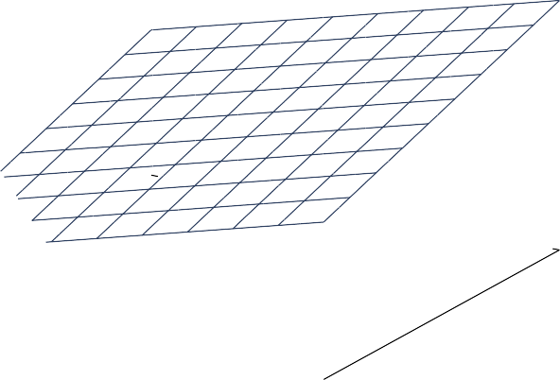

120

140

100

1

80

2

3

4

0 20

4060

10

8

6

4

2

0

160

0

*Ecomp* = 1*.*51 · *Z* + 33*.*36 · *T* − 1930*.*21

Benchmark energy (GWhr)

In the study [40] used simplified Process Toolbox (PTB) simulation models to investigate cooling interventions.

The scenario Holman simulated showed potential average power reduction of 136 kW which would lead to an annual energy cost saving of R0.55M. The study could be improved by increasing accuracy of the simulation. Power difference of as high as 31% between the simulation and actual were observed for some time periods.

Simulation has added great value for mining compressed air DSM. A detailed literature discussion of compressed air simulation applications is discussed in Section 2.5.

### Simulation procedure

A structured simulation procedure is required to achieve the objectives of the study. Previ- ous studies from literature have focussed on how simulation software tools work rather the simulation procedure that was followed [41].

Bouwer [42] developed a software tool that he used to investigate large thermal and and energy. Bouwer used the following procedure to implement simulations:

* + - 1. Create a detailed schematic of the system
      2. Obtain data from installed instrumentation
      3. Perform manual measurements where necessary
      4. Gather data for a typical operational period
      5. Convert data into useful formats
      6. Set-up the simulation model
      7. Calibrate the model until simulated outputs match measured data

Bouwer’s simulation procedure provides a good guideline for mining system simulation. The procedure could be simplified by merging steps. For example step 1 to 4 could be merged into 1 step “Gather system data and information”.

#### Periodic/repeated simulation

The concept of periodic or repeated simulation procedure the execution a simulation multiple times or on a recurring schedule whilst altering various input parameters. [15] used repeated estimation to determine an upper and lower bound for the expected result. Another example from industry is real time simulation or estimation systems.

Van Heerden *et al.* [43] developed a dynamic control system for a mine compressed air network. The controller utilised repeated simulation to estimate unmeasured and future parameters of the network. This was used to optimise the compressor control.

Hollander and Lui [44] used repeated simulations to estimate travel time distributions for traffic networks. [44] developed the following methodology for the repeated simulations:

1. Gather input parameters
2. Run simulations
3. Read simulation outputs
4. Repeat for desired iterations

### Available simulation tools

A software tool is required to create and execute the compressed air simulations. In literature variety software tools have been used to simulate industrial systems. A suitable software sys- tem for this study must be capable of producing accurate models of complex compressed air network. The system should be able solve for transient compressed air simulation scenarios with dynamic data and control inputs.

The development of system models should also not be excessively time-consuming. The

software tools should also be able to handle missing data inputs and information that in common in mining systems. These were shortfalls of simulation tools noted by van Tonder

1. and Marais [41].

The following simulation tools that may meet the criteria were identified :

* + PTB
  + Flownex
  + KYPipe GAS
  + AirSim
  + REMS

Of these tools, PTB was identified as the most suitable software system for this study. Whilst it may be possible to use other packages, PTB was developed specifically for simulation of mining systems. This allows simpler and speedier development of system components as many components such as compressor mathematical models have already been pre-built [41].

### Simulation model verification strategies

Due to lack of instrumentation, measurement inaccuracies and other non-ideal aspects of mining systems. It is impossible for a simulation model to match the actual system’s perfor- mance perfectly. From literature, methods of verifying simulation precision were investigated. The verification techniques identified from literature were Mean residual difference, Mean Absolute Error (MAE), coefficient of determination or correlation and Mean Square Error (MSE).

#### Mean residual difference method

The average difference method looks at the average for the data points in the actual and simulated time series. Relative error is then calculated with eq. (2.1). The simulation percentage error in relation to the actual series is then calculated by dividing the error by the Actual data-points, eq. (2.2).

*R*¯ = 1

*N*

*N*

*n*=1

(*An* − *Sn*) (2.1)

To get a relative error percentage, the equation is rewritten:

Where:

*Err*%

= 1

*N*

*n*=1

*An* − *Sn*

*An*

(

× 100% (2.2)

*A* Actual system time series

*N*

*S* Simulation time series

*n* Data point

*N* Number of Data point in simulation period

A major disadvantage of this method is that for transient simulation, the positive and nega- tive errors for individual points can cancel out. This leads to a smaller resultant error than would be expected. The resultant error therefore can not lead to any conclusive statements regarding the accuracy of the model [46]. This strategy is not recommended if used alone to verify transient simulations.

Yu-jie Xu *et al.* [47] developed a steady state simulation of an absorption chiller. In the study [47] utilised residual difference to measure the relative steady state error of the absorber model. The accepted margin of accuracy in the study was a relative steady state error of 5%.

#### Mean absolute error method

The MAE verification method follows a similar calculation as in the Average residual differ- ence method. However, as shown in eq. (2.4), the error is calculated individually for each point in the series. The average of the individually errors is the resultant error, eq. (2.3). To obtain the relative error percentage, each error is divided by the Actual value at that time step as in eq. (2.4).

1

*MAE* =

*N*

*N*

|*An*

*n*=1

− *Sn*

| (2.3)

To get a relative error percentage, the equation is rewritten:

1

*N*

*An* − *Sn*

*n*

*Err*% = *N*

*n*=1

*A* × 100% (2.4)

Where:

*A* Actual system time series

*S* Simulation time series

*n* Data point

*N* Number of Data point in simulation period

#### Coefficient of determination

The Coefficient of correlation is the measure of how accurately a data series (*x*) can be represented in a linear relationship with Data series (*y*), i.e. *y* = *mx* + *c*. The value for the coefficient ranges between −1 and 1 where a value of 1 indicates a perfect linear relationship between the series and a value of -1 represents a perfect negative linear relationship. A value of 0 indicate that there is no relationship between the data series. The correlation coefficient can be calculated using equation eq. (2.5).[46]

*r* = I),*N*

*N*

*n*=1

),

*n*=1(*An* − *A*¯)2 ·

(*An* − *A*¯)(*Sn* − *S*¯)

),*N*

*n*=1(*Mn* − *A*¯)2

(2.5)

Where

*A* Actual system time series

*S* Simulation time series

*n* Data point

*N* Number of Data point in simulation period

The coefficient of determination or R-Square value can be calculated by squaring the corre- lation coefficient (r).

Kurnia *et al* [48],[49] developed a simulation for a novel underground mining ventilation system. [48],[49] selected the mathematical model with the highest precision when compared with historical data points. The chosen model had an R-Square value of 0.96 and a relative error 30 %, using the mean absolute error method.

#### Mean squared error

In statistics, the MSE or Root Mean Square Error (RMSE) is the average of the square of the error between the actual and estimated value. The value is always positive. A smaller

value relates to a more accurate model.4

1

*MSE* =

*N*

*N*

(*An*

*n*=1

* *Sn*

)2 (2.6)

Where:

*A* Actual system time series

*S* Simulation time series

*n* Data point

*N* Number of Data point in simulation period

#### Other methods

A number of additional methods or variations of the methods discussed are available to verify transient simulations. As an example, [50] looked at the percentage of relative errors under a certain limits as well as a maximum relative error. The method is an improvement compared to residual difference in ensuring transient simulation accuracy however the results are difficult to interpret.

Sarin *et al* [46] compared many methods. Some methods that have not been discussed in this study include:

* + Vector Norms.
  + Sprague and Geers Metric [51],[52]
  + Russells error Measure [53],[54]
  + Normalized Integral Square Error
  + Dynamic Time Warping (DTW).

The calculations in the above methods are relatively complex. However, they provide addi- tional metrics such as Phase, magnitude and slope errors. These metrics could add value in verifying simulations.

#### Comparing verification methods

The difference between the strategies is best shown using an example. Figure fig. 2.7 shows the output and actual power of a simulation of a mining system for a 24 hour duration. In the study [41] used mean residual difference, eq. (2.2), to determine the accuracy of a simulation model.

4 University of Kentucky Department of Mathematics, ”Estimators, Mean Square Error, and Consistency” [Online] [http://www.ms.uky.edu/~mai/sta321/mse.pdf](http://www.ms.uky.edu/%7Emai/sta321/mse.pdf), [Accessed 3 March 2017].

Positive and negative differences between the simulated and actual profiles cancelled out, meaning the average value of the two power profiles were very similar. The calculated residual difference relative error was therefore calculated as 1.17%. However, Using the relative error, eq. (2.4), applied to the same data series results in a relative error of 15.2%. The results of the verification strategies on the example is provided in section 2.4.6.

10

9

8

7

6

5

4

3

2

1

0

10

9

8

7

6

5

4

3

2

1

0

02:00 04:00 06:00 08:00 10:00 12:00 14:00 16:00 18:00 20:00 22:00 00:00

Time of Day

AE % Actual power

SE % Simulated power

MAE % Average Actual

MSE % Average Simulation

Power (*MW* )

Relative *Err*%

Residual difference

MSE

MAE

Figure 2.7: Example of simulation error calculations. Data adapted from Mar`e [41]

|  |  |  |
| --- | --- | --- |
| Verification method  Residual Difference | Result  0.06 MW difference | *Err*%  1.17% |
| MAE | 0.778 MW error | 15.2% |
| MSE | 1.236 | - |
| Coefficient of determination | *r*2 = 0*.*857 | - |

Table 2.1: Results of the comparison of verification methods.

Willmott [55] studied the Advantages of the use of mean absolute error MAE over the RMSE method in assessing model accuracy. In the study [55] concluded that the MSE measure is a function of MAE and therefore does not describe average error alone. From the analysis MAE was described as the most natural and unambiguous measure of average error magnitude.

#### Verification usage in previous simulation studies

Previous studies verified simulation accuracy through different methods and varying degrees of precision. table 2.2 summarises these approaches. The majority of local literature utilised the mean residual difference to determine the estimation accuracy. However, from literature it clear that the mean residual does not necessarily indicate model accuracy.

*Err*% *<* 10% and

|  |  |  |  |
| --- | --- | --- | --- |
| Study | Year | Verification method | Accepted margin |
| Arndt [50] | 2000 | Mean and maximum absolute % error | % of time where  *Err*% *<* 5% |
| Bouwer [42] | 2004 | Mean residual % difference | *Err*% *<* 10% |
| Marais [8] | 2012 | Mean residual % difference | Not specified |
| Van Niekerk [39] | 2012 | Mean residual % difference | *Err*% *<* 10% |
| Bredenkamp [31] | 2013 | Mean residual % difference | *Err*% *<* 10% |
| Holman [40] | 2014 | Mean residual % difference | Not specified |
| Kriel [8] | 2014 | Mean residual % difference | *Err*% *<* 10% |
| VanTonder [45] | 2014 | Mean residual % difference | *Err*% *<* 3% |
| Kurnia *et al* [48],[49] | 2014 | Coefficient of determination Mean absolute error | *r*2 *>* 0*.*95  *Err*% *<* 30% |
| Dominic [56] | 2014 | Mean squared error | *<* 1*.*7*e−*3 |
| Du Plessis *et al.*[57] | 2015 | Mean residual % difference | *Err*% *<* 7% |
| Pascoe [33] | 2016 | Mean residual % difference | *Err*% *<* 5% |
| Peach [58] | 2016 | Mean residual % difference | Not specified |
| Mare [41] | 2016 | Mean residual % difference | *Err*% *<* 5% |
| Yu-jie-Xu *et al* [47] | 2016 | Mean residual % difference | *Err*% *<* 5% steady state |

Table 2.2: Simulation verification methods that were implemented in previous studies.

### Summary

In this section the usage of simulation and estimation techniques to identify improvements in in mining industry was reviewed. Estimation and benchmark procedures in literature were first discussed. A review of simulation usage in mining DSM for water, compressed air and cooling systems was then discussed.

Simulation procedures in literature were discussed. Various simulation software tools used in industry were than compared. Finally an analysis and comparison of verification procedures was performed.

## Use of simulation in mining compressed air opti- misation

### Preamble

This section will focus on discussion of literature regarding simulation usage in optimising mining compressed air systems. Shortcomings identified from literature that can be improved upon in this study will be addressed.

### Simplified compressed air simulation models

#### Simplified ”vessel” model

Before new software tools allowed for the development of detailed mining compressed air simulation models, Marais [[8],12] created a simplified compressed air model to estimate and quantify the performance of potential energy interventions. [8] simplified the mining compressed air system, comparing the network to an air source and a vessel with many leaks. This is illustrated in fig. 2.8.

Figure 2.8: Simplified compressed air network model. Adapted from Marais [8].



Compressed air supply (S)

Productive leaks (P)

Non-productive leaks (N)

S = P+N

A simplified calculation methodology was developed to quickly estimate the expected energy savings impact on the system. From this, energy saving estimations rules were developed as listed in table 2.3.

There is not a high degree of precision in this approach as specific details regarding the air

Intervention Estimation rule

∝ ·

Reducing compressor deliver pres- sure

*x*% pressure reduction (1.6 to 1.8) *x*% power reduction

Reduce control valve pressure *x*% pressure reduction *p x*% power reduc-

∝ ·

tion.

Where p is the valves’ relative flow con- tribution to the system

Reduction of flow *x*% flow reduction ∝ *x*% power reduction

Table 2.3: Summary of energy saving estimation rules[8].

network are not taken into account. The simplified approach cannot be used to estimate more complex scenarios. The method also does not estimate other potential benefits of interventions such as pressure delivery improvements.

#### Simplified air network model

Kriel [26] used simulation to estimate the performance of energy projects on mining com- pressed air. The KYPipe GAS software tool was utilised to develop simulation models for the systems. [26] simplified the air networks for the simulations to a single compressor rep- resenting the supply processes and an outlet flow to each underground level in the network. The model is shown graphically in fig. 2.9

Simulation was performed to quantify the savings from underground network interventions. The interventions were deigned to reduce flow to the network. The estimated savings from the simulations varied between 10 and 25% compared to the actual performance of the interventions. Like the vessel model discussed previously, the simplified air network model can not be used to estimate the energy savings potential of more complex scenarios. The simulation procedure in this study could be improved by using a more detailed model and a more precise verification method. This would lead to savings predictions with higher accuracy.

Pin

F1 F2 F3 F4

F5

Figure 2.9: Simplified system model. Adapted from Kriel [26].



Compressors

FTotal

Pout

P1 P2 P3 P4

P5

### Complex compressed air simulation models

#### Compressor relocation

Simulating compressor relocation requires air supply details that were neglected in the sim- plified simulation such models discussed in this section. Bredenkamp [31] therefore developed simulation models to test such compressor relocation scenarios.

The model takes into account the location, supply capacity of each compressor, as well as the surface pipe distances. The model, as visualised in fig. 2.10, simplifies the air demand to an outlet flow per shaft.

[31] utilised the residual difference to calibrate and verify the model parameters. Simulation precision and estimation confidence could therefore be improved through use of the other verification methods discussed in section 2.4.6.

Increasing the complexity of the demand components would provide more detailed results, showing more specific effects that result from the simulated scenarios. Additionally more complex scenarios could be simulated with potentially greater savings

1750 m

Figure 2.10: Compressor relocation simulation model. Adapted from Bredenkamp [31].

5# compressors

4# compressor

5# Flow

1720 m

400 m

Air flow

Compressor

4# Flow

#### Compressed air ring

Pascoe [33] developed a simulation model for a compressed air ring. The purpose of the simulation was to identify the benefits of reducing pressure during the blasting shift period though valve control.

The model required complex supply side detail including modelling of individual compressor, locations of compressors and pipe lengths and control valves. The demand aspect of the system was simplified to a single flow per shaft, decline or processing plant. A schematic of the simulation model is shown in fig. 2.11.

As was the case with Bredenkamp [31], [33] utilised the residual difference to calibrate and verify the model parameters.The precision could therefore also be improved through the use of the other verification methods discussed in section 2.4.6. Increasing the complexity of the demand components could also be beneficial.

#### Mine complex

Mar´e *et al.* [19] developed a compressed air simulation for a mining complex. In the study

[19] simulated and prioritised several scenarios with the goal of reducing energy and other

Figure 2.11: Simplified compressed air ring model. Adapted from Pascoe [33]. operational costs.



Decline A

Shaft D

Closed Decline

Decline B

Smelter plant

Shaft C

Shaft B

Air flow

Compressor

Shaft A

Mar´e accurately modelled the individual compressors at each shaft in the mining complex. The detailed flow consumption at individual mining levels was found to be inaccurate. [19] therefore selected the process boundary for the model to include only the air flow consump- tion at the shaft. A process schematic for the simulation mode is shown in fig. 2.12.

55L

Compressor



Shaft N

Shaft P

Shaft T

Mine shaft

Control valve

Air flow

66L

66L

Bottom levels

Figure 2.12: Simulation model for a complex air network. Adapted from Mar´e *et al.* [19].

Using the model, 8 scenarios were simulated. The combined results showed that there was a potential energy saving of R1.5M as well as an additional pressure improvement of 51 kPa.

The infrastructure and resource costs were estimated in order to prioritise the interventions for the greatest financial benefit to the mines.

[19] used residual difference to calibrate and verify the accuracy of the transient simula- tions. Therefore, the actual estimation error is therefore greater then what is shown in the study. Through on site inspections and strategic measurements, the detail of the simulation model could be improved this could allow for more accurate simulations and more simulation scenarios.

### Summary

Previous work in compressed air simulation was summarised and discussed in this section. Simplified and complex simulation models were discussed separately. Some of the shortcom- ings for simplified simulations was that they only provided generalised power saving results for the simulation.

The complex simulation models focussed on the details required for the scenarios that were simulated. Other aspects of the models were simplified as much as possible. This resulted in accurate, detailed results compared to the simplified models. However, adding further com- plexity and detail could increase the the accuracy and allow for more simulation scenarios.

## Conclusion

In Chapter 2, a comprehensive study of relevant literature was performed. the aim of the literature study was to :

* + - Provide background on mining compressed air networks
    - Review compressed air energy interventions in industry
    - Review the usage of simulation in the mining industry
    - Review the usage of simulation in the mining compressed air

Compressed air background was provided. This included background regarding various com- pressed air sub-components, the operational schedules and the effect on compressed air re- quirements and finally the typical instrumentation found in a mining compressed air system.

A review of previously achieved energy improvements in compressed air was the performed. The literature were divided into studies that focussed on improving the supply of compressed air and those that optimised the compressed air demand.

The usage of simulation and estimation in mining industry was then reviewed. Estimation and benchmark procedures in literature were first discussed. this was followed by a review of simulation usage in mining DSM. Simulation procedures from literature were then discussed. Various simulation software tools used in industry were compared. Finally an analysis and comparison of verification procedures was performed.

Finally, the usage of compressed air simulation was reviews. This included a discussion of simplified and complex simulation models. The shortcomings and success of previos studies were discussed.

## CHAPTER 3

**Developing a simulation methodology**

‘*Great Design is iteration of good design.*’ - Dr M. Cobanli

## Introduction

This chapter details the implementation methodology of simulations to optimize mining compressed air systems. The methodology discussed in this chapter will utilize insights from previous studies. Improving on shortcomings discussed in section 2.5.4.

Implementation of a simulation is divided into three steps as shown in the flow diagram, fig. 3.1. Firstly, an investigation on the specific air network to is performed. The data acquired from this investigation is then utilized to develop and verify a simulation model. In the final step, scenarios are tested using simulations and the results are quantified and prioritised. After the process has been reviewed, a simulation report is then produced and passed to the mine.

Investigation the system

Develop a simulation model

Verify the simulation model

Execute the simulation

Analyse the results

Correct errors

Apply scenarios

Review the process

Prioritise operational interventions

Report results to the mine

Figure 3.1: Flow diagram of the methodology for this study.

## Investigate the system

### Preamble

Developing a detailed simulation model of a compressed air network requires thorough com- prehension of the inner workings of the system. This section will discuss the investigations needed to obtain the required understanding.

### Acquire data

The first step of the system investigation is to acquire the data and understanding that will be required to model compressed air system’s function. This will require access to mine

resources such as data storage systems, instrumentation, and communication with relevant engineers and personnel.

Comprehensive and up to date layouts illustrate a compressed air network’s unique set- up, scale and location of instrumentation. More detailed layouts can provide per-level air consumption breakdowns of the network, locations of refuge bays, mining cross-sections and identified inefficiencies. This is vital to understand the operation and identify what data parameters will be required for the model.

A baseline period that best represents the typical operation of the mine. Additionally, availability of data should be considered. The length of the baseline period is selected based on the scenarios that are to be tested, this can be changed later. For calibrating a compressed air system a 24 hours period of normal operation is usually sufficient. A longer period may be needed to verify the model. Next data

### Investigate mining schedules

A critical aspect to developing an accurate model of a mining compressed air system is apprehension of the operational philosophy of the mine. The schedule for operations such as drilling, blasting or cleaning can have a major impact on compressed air requirements at different times of the day. By utilizing the operational schedule, simulation scenarios can be optimized for the air requirements throughout the day.

### Verify data accuracy

Data verification is the process where data is evaluated to ensure accuracy. It is important to verify data that is used for model development as an accurate representation of the operation of a system can only be achieved utilising data of high quality [59]. The factors that influence a data-set’s quality, accuracy and integrity summarised as follows:

* + - * Conversion of measurement value [60]
      * Storage and collection of the system [61],[62]
      * Traceability of measurement sources [62]
      * Measurement equipment accuracy and malfunctions [59]
      * Data abnormalities [59]

Therefore, a data verification methodology is utilised to ensure datasets are of high quality.

### Resolve unavailable data

Parameters that are required to develop the simulation model, such as flows, pressures, may not be actively logged by mine systems. To obtain this data it is necessary to investigate alternative sources. At points where instrumentation is absent, estimations can be made from assumptions made using instrumentation on the network or spot inspections.

Air network specifications such as piping sizes, technical layouts, major leak locations or specifications is often outdated or not recorded. Critical data should be obtained through audits and inspections of the system. If manual inspection is not possible, estimations should be made using the available data or approximation techniques discussed in literature.

### Summary

This section discussed the procedure to investigate a compressed air system. This includes acquiring data and information regarding the specific compressed air network, process to evaluate authenticate data accuracy as well as procedures to deal with situations where no data is available.

## Develop and verify a simulation model

### Preamble

Compressed air networks are comprised of components such as compressors, valves, pipes, etc. This section will discuss the development, calibration and verification of component models that make up a compressed air simulation.

### Select the process boundaries and simulation parameters

The simulation boundaries determine the detail that the system process is modelled. For a simple compressed air model, the boundaries can be set around the compressor house. This model would then only include the compressor components, inlet and outlet airflows. Alternatively a more complex model can be developed by choosing boundaries to include more aspects of the process such as mining levels, gold plants etc.

The boundaries should be chosen based on the input data available, accuracy targets and available time and resources. A more detailed model will lead to more accurate simulation, however it may take more time and resources to obtain the data required to calibrate the model. Figure fig. 3.2 shows an example of different boundary selection for the same system.

Boundary 1

Boundary 2

Boundary 3

Air In

Figure 3.2: Selecting boundaries for the simulation model.

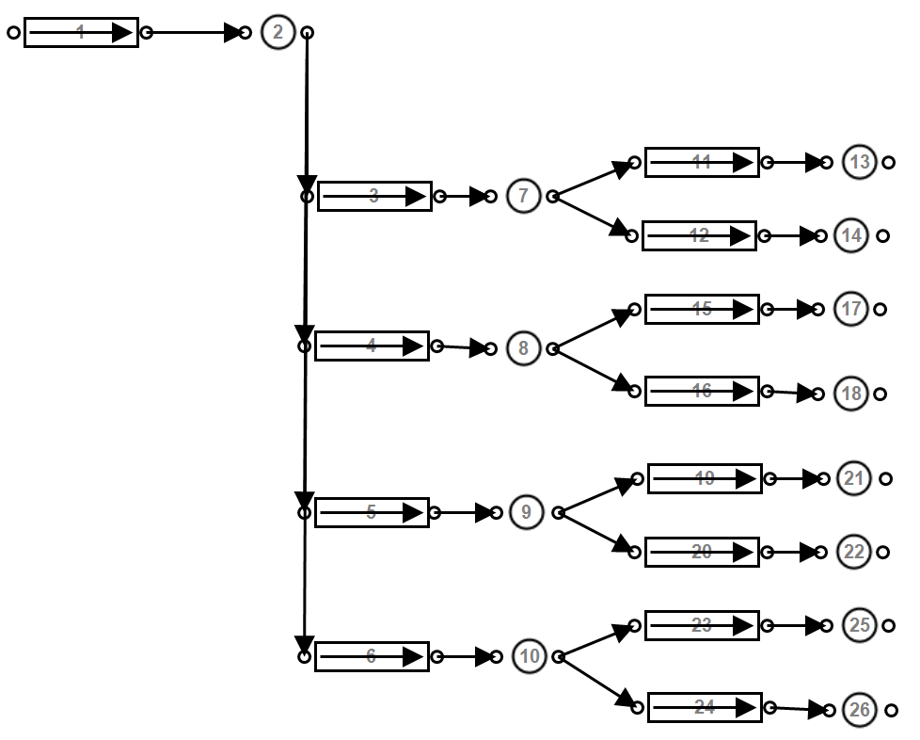

period and data step sizes of the simulation is just as important. The period or duration of the simulation should be determined to ensure that the effects of a scenario are fully tested. Most commonly, previous studies have simulated a ”typical” 24 hour period of operation. Most mining compressed air systems follow daily trends and patterns. Therefore, there is no need to simulate a longer period as day to day results would be very similar. A longer simulation may be required in cases where the system operation varies from day to day.

The simulation step size indicates the data resolution. A lower step size will result in a more accurate simulation of the system, however the processing and data analysis is effected. In this study, the smallest available step size1 is selected to ensure that the simulated results achieve the desired precision. Higher step sizes (30+ min.) complicates control models as replicating quick changes such as opening/closing valves or compressors stopping or staring etc. precisely becomes more difficult.

Higher time-step resolution allows for more precise tuning of controllers and dynamic com- ponents. If input data is not available in the desired resolution, the data can be interpolated using the appropriate method. An example of the application of linear interpolation to in- crease the time-step resolution is shown in fig. 3.3. However, estimating the “in-between” time-step value incorrectly may adversely affect the simulation accuracy.

1 The minimum step size is determined from the logging interval of the input data instrumentation. For example if all input data is logged at 10 minute intervals, the minimum step size would also be 10 minutes.

|  |  |  |  |  |  |
| --- | --- | --- | --- | --- | --- |
|  |  |  |  |  |  |
|  |  |  |  |  |  |
|  |  |  |  |  |  |
|  |  |  |  |  |  |
|  |  |  |  |  |  |
|  |  |  |  |  |  |
|  |  |  |  |  |  |
|  |  |  |  |  |  |

Figure 3.3: Interpolating input data to increase time-step resolution.

14

12

10

8

6

4

2

0

00:00

04:00

08:00

12:00

Time of Day

16:00

20:00

00:00

Interpolated datset Orginal dataset

### Model compressed air network components

#### Air pipes

Pressure losses occur over compressed air networks due to friction in the pipe, these losses should be taken into account in the simulation for large piping sections. A pipe model is used to account for these losses which are defined by the *Darcy-Weissman equation*2:

∆*P* =

*f LρV* 2

2*D*

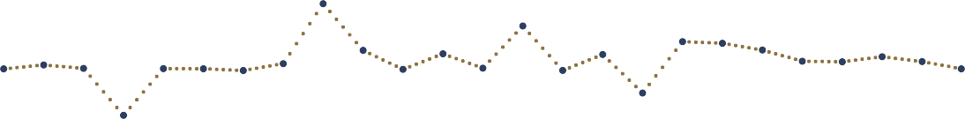

c/kWhr

Where the pressure difference ∆*P* is a function of:

Parameter Definition

*f* Friction coefficient

*L* Pipe length (*m*)

*D* Pipe diameter (*m*)

*ρ* Air density (*kg/m*3)

*V* Average velocity (*m/s*)

Table 3.1: Air pipe component model parameters.

The pipe component can be used as a valve by controlling the open fraction between 0 and

1. Modelling the valve flow characteristics is discussed in section 3.3.3 *Controllers*.

2 B. Glenn, ‘The Darcy–Weisbach Equation,’[Online] [https://bae.okstate.edu/faculty-sites/Darcy/](https://bae.okstate.edu/faculty-sites/Darcy/DarcyWeisbach/Darcy-WeisbachEq.htm) [DarcyWeisbach/Darcy-WeisbachEq.htm](https://bae.okstate.edu/faculty-sites/Darcy/DarcyWeisbach/Darcy-WeisbachEq.htm), [Accessed 20-05-2017]

#### Ambient conditions

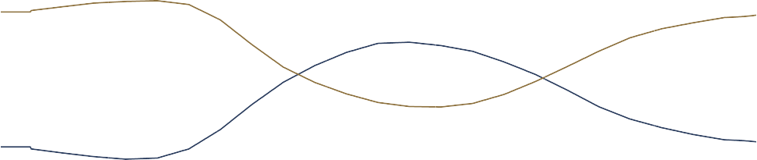Ambient air condition underground and on surface change the characteristics of the air, effecting the operation of the system. fig. 3.4 shows the average summer air conditions. If no data is available for the specific simulation period, the conditions can be estimated by scaling this profile. The assumption is made that underground conditions remain constant

35

100

30

80

25

60

20

40

15

20

10

00:00

04:00

08:00

12:00

Time of Day

16:00

20:00

0

00:00

Temperature Relative Humidity

Relative Humidity (%)

Temperature ()*◦C*)

|  |  |  |  |  |  |
| --- | --- | --- | --- | --- | --- |
|  |  |  |  |  |  |
|  |  |  |  |  |  |
|  |  |  |  |  |  |
|  |  |  |  |  |  |
|  |  |  |  |  |  |

Figure 3.4: Average summer ambient air conditions at a South African gold mine.

at each mining level. Pressure and temperature increases with depth as a result of auto compression and rock face temperature. Therefore, the conditions can be estimated using only the depth at each level.

#### Compressors

Three compressor models were investigated, each with varying complexity. The models are:

* + Air compressor
  + Dynamic compressor
  + Positive displacement compressor

The air compressor is a general, simplified model. It requires minimal user inputs by making several assumptions. This is useful when parameters for a compressor are not available. Or when doing a quick preliminary simulation. However, it is not ideal for detailed simulations which require more precision.

The dynamic compressor components are is more complex, taking into account factors such as heat generated by polytropic

coefficient and inefficiencies within the process. Hence, the model can be used more ac-

curately and for more complex simulations than the general compressor model. However, it should be noted that the dynamic compressor is simplified by several assumptions, for example, a constant efficiency at varying loads.

For most scenarios, the dynamic compressor model is most suitable. This component is modelled by fitting a quadratic curve through three points of operation to obtain an equa- tion for corrected mass flow as a function of the pressure ratio. This characteristic curve of compressor as shown in fig. 3.5 can be accurately estimated even when only one data point is available by making approximations for the zero flow and pressure points on the curve. Once the flow characteristics of the compressors are set, the efficiency and polytropic coefficient parameters are calibrated such that the output power and air temperature match the actual or estimated outputs of the compressor. Once the models are accurately cal-



500

400

300

200

100

0

0

2

4

6

8

Pressure ratio

10

12

14

16

Mass flow (*kg*3*/s/*/(*k*)*/Bar*)

|  |  |  |  |  |  |  |  |
| --- | --- | --- | --- | --- | --- | --- | --- |
|  |  |  |  |  |  |  |  |
|  |  |  |  | *f* (*x*) | = −2*.*586 | *x*2 + 7*.*78 | 8*x* + 494 |
|  |  |  |  |  |  |  |  |
|  |  |  |  |  |  |  |  |
|  |  |  |  |  |  |  |  |
|  |  |  |  |  |  |  |  |

Figure 3.5: Estimating the characteristic curve of a compressor by fitting a quadratic function to points of operation.

ibrated, the compressor component is integrated to the air network in the arrangement shown in fig. 3.6. The Compressor is connected to the inlet air source via an inlet pipe and air node and to the rest of the network via an air node and outlet pipe. This is is to allow the inlet and outlet parameters and conditions to be be monitored and controlled.

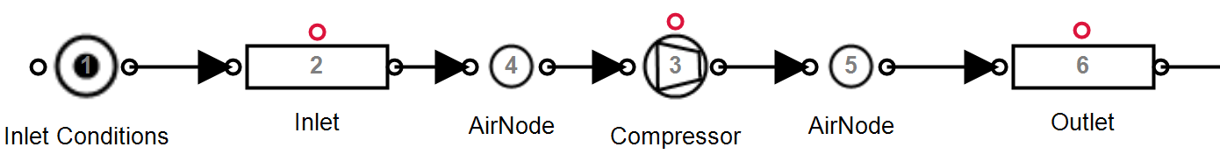

Figure 3.6: Integrating the compressor component into the simulation.

#### Demand/leak

A flow demand represents any air flow leaving the network. This includes equipment that uses air such as drills and agitators etc. as well as inefficiencies like leaks and open pipes. Generally the air flow is dependent on pressure and the specific resistance to flow of the outlet.

The resistance of the flow demand can be obtained using the inlet pressure, outlet pressure and flow. If the flow is not known, a reasonably accurate estimation can be made by calcu- lating the expected flow from the size of the outlet. The air demand may vary throughout the day. For example, a mining section may utilise more machines during certain periods of the day. A schedule is used to replicate this in the simulation. fig. 3.7 shows how a calibrated air demand or leak is integrated into the simulation.

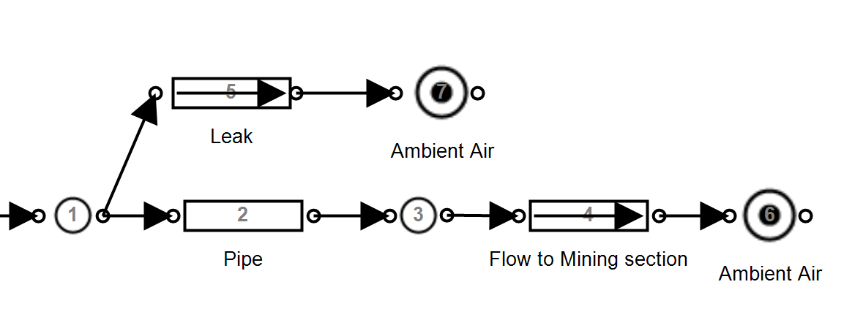

Figure 3.7: Implementing flow demands and leaks into the simulation.

#### Compressed air control

Simulation components need to be dynamically controlled as in the actual air network. Control is typically implemented on compressors and valves throughout the network to follow certain set-points and schedules. It is important to not only include the controllers in the simulation, but to replicate the non-linearities, limitations and responsiveness related to their use. This ensures the model reacts in the same way the actual network would, improving accuracy.

On a typical mine, compressors power is controlled to ensure that the discharge pressure matches a specified set-point. This control is achieved through either VSDs (or Variable Frequency Drives (VFDs)) and guide-vain control. VFDs provides a wide range of power control and can be estimated using a Proportional-Integral (PI) controller as in fig. 3.8 where discharge pressure is used as feedback for the controller. Guide vains are most commonly used in mining to control compressors. This entails controlling the position of the inlet guide vain . The guide vain is opened or closed to control the compressors discharge pressure.

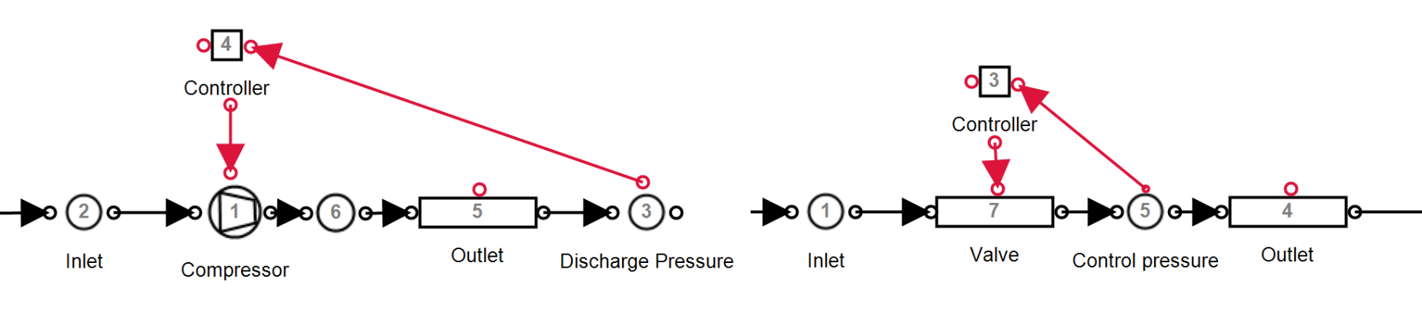

Figure 3.8: Control components in PTB.

Manipulating the guide vain position will affect the power the compressor inputs into the system. fig. 3.9 shows the relationship between power and guide vain position. This can be estimated as a linear function where a guide vain position of 40% relates to an output power of about 60% of the maximum power. When more pressure is required than can be obtained with the guide vains fully opened, another compressor is needed to operate. A guide vain

120

100

80

60

40

20

0

0

20

40

60

80

100

120

Guide Vain Position (%)

Output power (%)

|  |  |  |  |  |  |
| --- | --- | --- | --- | --- | --- |
|  |  |  |  |  |  |
|  |  |  |  |  |  |
|  |  |  |  |  |  |
|  |  |  |  |  |  |
|  |  |  |  |  |  |
|  |  |  |  |  |  |

Figure 3.9: Modelling the compressor control from a guide vain

controller is modelled using a PI controller. However, the non linear limitations of guide vain control, as represented in fig. 3.9, must be implemented in the controller. This is done by using a minimum control output limit that matches the minimum power reduction achieved by closing the guide vain to its minimum position. For example, a PI controller for the compressor from fig. 3.9 would have a minimum control output of approximately 60%.

Mines utilize control valves at underground sections to control the pressure at individual mining stations independently [63]. Controlling of valve components is performed similarly as control of the compressor components. As shown in fig. 3.8 the outlet pressure is used as feedback for a pi controller. The controller output is mapped to the valve fraction of a pipe component.

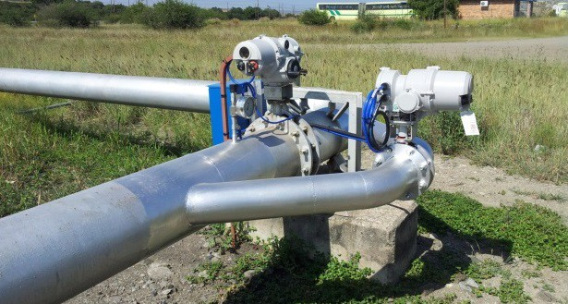

Figure 3.10: An example of a compressed air control valve[64]. Parameter Definition Unit

*A* The heat transfer area *m*2

*UA* Heat transfer coefficient *kW/◦C*

*Tamb* Ambient air temperature *◦C*

Table 3.2: The input parameters for the after-cooling simulation model .

#### Compressed air after-cooling

The air compression process generates significant heat. Compressed air at high temperatures contains a large amount of water vapour. To prevent condensation later in the air network, improve the system capacity and protect equipment from excessive heat, after-coolers are installed to the outlet of the compressor [27].

After-cooling reduces the compressed air temperature out of the compressors. This cooling can have an effect on the operation of the network. Hence, including after-cooling to the simulation model should improve accuracy. To replicate this effect, a heat transfer node can be added to the outlet of the compressor component. The heat transfer parameters shown in table 3.2 should be calibrated such that the air temperature matches after-cooled air temperature measurements. An assumption of 40 *◦*Celcius can be used if no measurements are available. Depending on the accuracy requirement, after-cooling can be excluded from the simulation. Post after-cooling, compressed air is normally still warmer then ambient conditions. Air temperatures underground can be accurately matched by including heat transfer for compressed air pipelines.

### Verify the simulation model

From the review of literature in section 2.4.6, it was determined that MAE and the coefficient of determination were the most effective methods of measuring model accuracy. Therefore, in this study both measures are utilised in the model verification. To obtain these measures, the major simulation outputs (Total system power, flow and pressure) are compared to actual data from the system. R-sqaured and MAE is obtained by applying the relative methodologies discussed in section 2.4.6.

For this study, the selected verification constraints were selected as :

*r*2 *>* 0*.*9 and *Err*% *<* 5%

If these constraints are met for the power, flow and pressure of the system,the model is considered accurate. As an extra measure relative error of the output for the minor model components should be *>* 85% of the actual data.

### Select simulation inputs

The inputs of a simulation are any parameters that do not remain static, or follow the same profile in day to day operation of the system. Examples of such parameters in a compressed air simulation are:

* + - * Surface ambient conditions
      * Machine operation schedules
      * Air demands
      * Operational changes

Changing the simulation baseline period for a calibrated simulation should only require the updating of the input parameters. fig. 3.11 shows an example of a changing compressor schedule where an input parameter would need to be updated in the simulation.

|  |  |  |  |  |  |
| --- | --- | --- | --- | --- | --- |
|  |  |  |  |  |  |
|  |  |  |  |  |  |
|  |  |  |  |  |  |
|  |  |  |  |  |  |
|  |  |  |  |  |  |
|  |  |  |  |  |  |
|  |  |  |  |  |  |
|  |  |  |  |  |  |
|  |  |  |  |  |  |

Figure 3.11: An example of two baseline periods, showing a changed compressor schedule.

8

7

6

5

4

3

2

1

00:00

04:00

08:00

Period 1

12:00

Time of Day

Period 2

16:00

20:00

00:00

Compressor

### Periodic simulation

Period simulation refers to the repetition of simulations over subsequent periods to determine the sequential accuracy of the model. This is important to verify the model is valid in general and not just a single period. This simulation will also indicate where operation changes have occurred as the simulation accuracy will be reduced.

The following process is followed to implement periodic simulation: Simulation input data is collected periodically for each simulation interval, this data includes only inputs that vary day to day such as schedules, air conditions and measured flows. Once the input values are collected, they are then imported into the compressed air model. The simulation performed and the output data is exported for analysis. The simulated data is then compared with the actual operation of the system and major discrepancies are identified. This process is triggered periodically.

### Summary

The simulation model development and verification procedure was discussed in this section. The selection of the model boundaries and simulation parameters were first discussed. This was followed by the modelling procedures for compressed air subcomponents. The verifica- tion procedure and constraints were then discussed with reference to the analysis performed in section 2.4.6. The simulation input selection procedure was then discussed. Finally a procedure for repeated/periodic simulation was provided.

Figure 3.12: The periodic simulation process that was followed in this analysis.

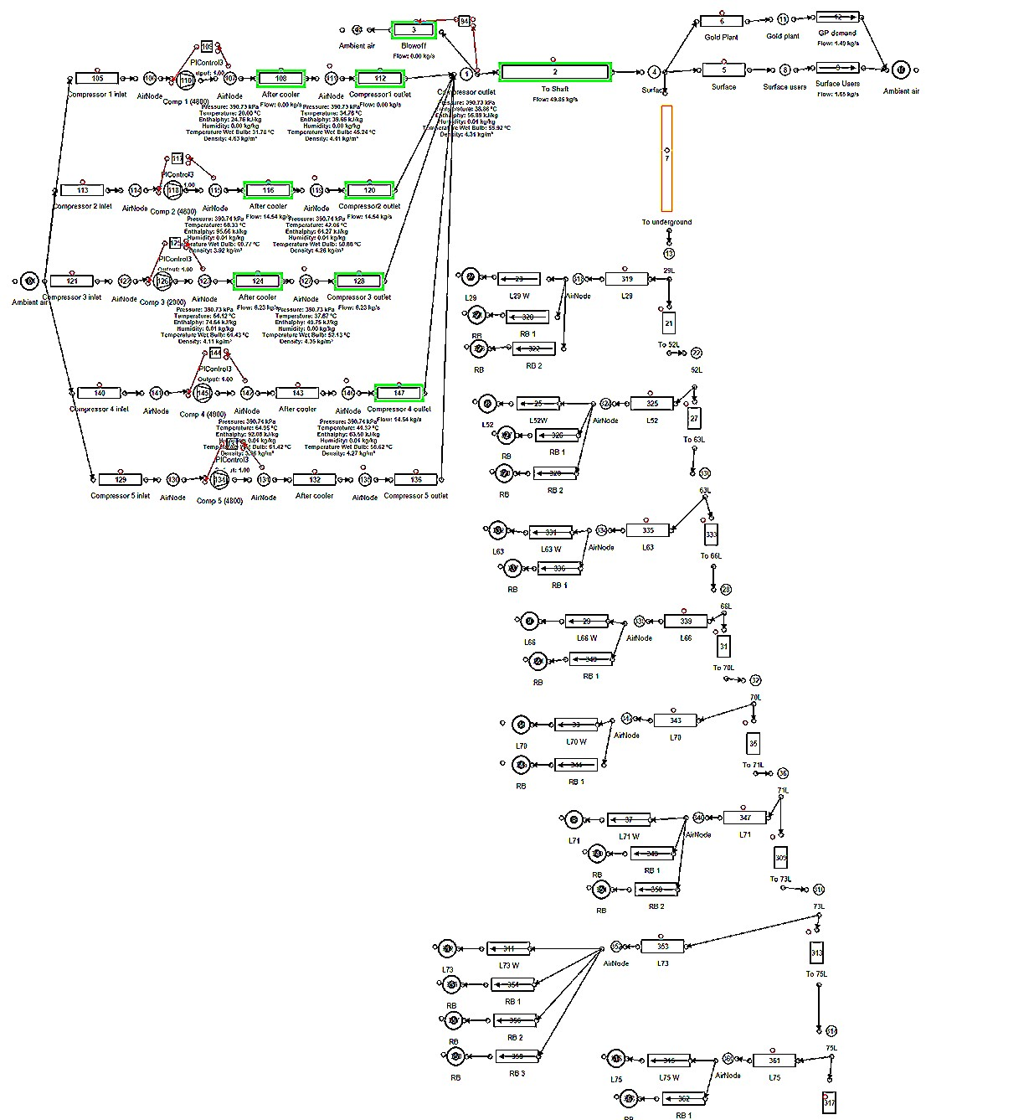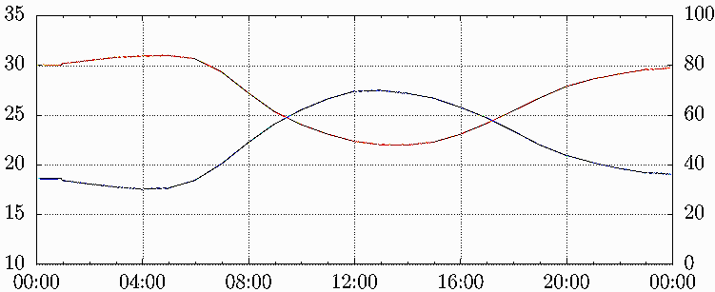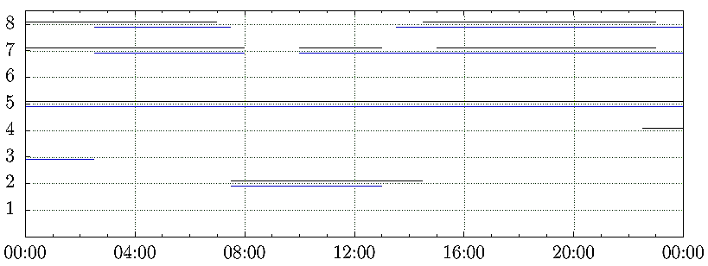

Analysis

Data sources

Update simulation inputs

Repeat periodically

Import into simulation model

Solve simulation

Export Simulation output data

## Implement the simulation

### Preamble

Once a simulation has been developed and verified, the implementation of interventions and scenarios follows. In this section, the approach of implementation the simulation methodol- ogy, and analysis of interventions will be discussed.

### Execute simulation scenarios

At this point the simulation model has been verified using historical data. The verified output data series is now used as baseline upon which the success of improvements scenarios can be quantified. The simulation inputs of the model are now adjusted in order to create the desired scenario. For example to create a scenario where a specific compressor is shut down over a period, the input schedule of the compressor is adjusted in the simulation model.

The simulation is then executed and this process is repeated for each of the scenarios. For each scenario, the desired output parameters must be exported for further analysis.

### Quantify operational benefit

With the data for each of the simulated scenarios exported, the relative improvement com- pared to the baseline should now be quantified. This is performed by comparing the baseline and optimised data series as shown visually in fig. 3.13. For power data, the expected an-

12

1

0*.*75

8

0*.*5

4

0*.*25

Time of Day

Baseline

Scenario Power saving

Power (*MW* )

Power Saving (*MW* )



0

00:00

04:00

08:00

12:00

16:00

20:00

0

00:00

Figure 3.13: An example of a baseline vs. optimised power comparison.

nual energy cost saving can be calculated using average weekday energy saving and the tariff structure provided by Eskom. The energy supplier’s weekday Time Of Use (TOU) tariffs for both the high demand (Jun - Aug) and low demand (Sep - May) seasons are shown in fig. 3.14.

Time of Day

High demand season Low demand season

c/kWhr

300

250

200

150

100

50

0

00:00

04:00

08:00

12:00

16:00

20:00

00:00

Figure 3.14: Eskom’s weekday TOU tariff structure.1

Estimating the cost benefit for improvements in pressure delivery is more difficult to quantify.

1 Eskom, ”2017/18 Tariffs and charges” [Online] [http://www.eskom.co.za/CustomerCare/](http://www.eskom.co.za/CustomerCare/TariffsAndCharges/Pages/Tariffs_And_Charges.aspx) [TariffsAndCharges/Pages/Tariffs_And_Charges.aspx](http://www.eskom.co.za/CustomerCare/TariffsAndCharges/Pages/Tariffs_And_Charges.aspx), [Accessed 28 June 2017].

Instead, the average pressure benefit should for a period should be provided in kPa. For ex- ample, “The simulation indicated an *x* MW saving with an additional pressure improvement of *y* kPa during the drilling shift.”.

### Report results to the mine

Once the benefits for each simulated scenario has been calculated and quantified, the in- terventions should be prioritised in the order of greatest benefit for the mine. The imple- mentation costs and pay back periods of the interventions can also be considered in this process.

The results and recommendations should be submitted to responsible mine personal in the form of a report. At this point the process of implementation becomes the mines responsi- bility. The mine may require further validation of the results through practical testing.

### Summary

This section discussed the of implantation of the simulation procedure. Implementation involves execution of the simulation scenarios, followed by the numerical calculation and quantification of energy cost savings and other benefits. Finally the procedure to report findings to the mine is given.

## Conclusion

The aim of chapter 3 was to provide a methodology to develop compressed air simulations. The method was broke into three steps:

* + 1. Investigate the system
    2. Develop and verify a simulation model
    3. Execute the simulated scenarios and quantify the benefits

This investigation step involved obtaining and verifying data and information regarding the compressed air network. Processes to resolve scenarios where data can not be obtained were also provided.

In the next step, a simulation model development and verification procedure was provided. This included the selection of model and simulation parameter, the development of sub- component models as well as a verification procedure A methodology for repeated/periodic simulation was also provided.

The final step involved the execution of the simulation followed by the methods to calculate, quantify and report potential benefits of the simulated scenarios.

## CHAPTER 4

**Results and validation**

‘*It doesn’t matter how beautiful your theory is, it doesn’t matter how smart you are. If it doesn’t agree with experiment, it’s wrong.*’ - Richard P. Feynman

## Introduction

This section will validate the simulation methodology through case studies. Mining com- pressed air systems were chosen as case studies based on the availability of data and the scope for energy and operational improvement. Two different mines were selected for the studies.

Three case studies were performed. In case study 1 and 2, improvements were simulated on mine A and mine B respectively. In Case study 3 periodic simulation analysis is implemented using the simulation developed for case study 2. From the results in the case studies, the potential benefits compressed air simulations for the South Africa mining industry is estimated and discussed.

## Case study 1. Simulated improvements on mine A

### System investigation

Mine A represents a group of three gold mining shafts and a gold processing plant in the Free state province. The mine shafts and gold plant share a compressed network. Prior to this study, efforts had been made to optimise the system through DSM energy projects. However, there may still be potential for further optimisation. An investigation was performed to gather data and understanding of the system and to identify potential energy and operation improvement strategies.

An air flow distribution layout was developed for the system, a simplified layout is shown in fig. 4.1. From this along with information from the mine personal and data, an understanding of the air network’s operation was obtained. The system typically utilises 5 *MW* of power. During the drilling shift the demand increases to 6 *MW* . fig. 4.2 show the average weekday power profile between January and May 2016.

Inlet air

VK32 6

VK10 1

VK10 2

VK32 1

VK32 2

VK32 3

VK32 4

VK32 5

Gold Plant

#2 Shaft

#1 Shaft

#3 Shaft

22L

23L

24L

25L

14L

15L

16L

17L

18L

19L

20L

21L

22L

23L

Online Standby Air flow Compressor



Control valve

24L

25L

26L



Figure 4.1: Simplified process flow chart of the compressed air network.

|  |  |  |  |  |  |  |
| --- | --- | --- | --- | --- | --- | --- |
|  |  |  |  |  |  | |
|  |  |  |  |  |  |  |
|  |  |  |  |  |  | |
|  |  |  |  |  |  | |
|  |  |  |  |  |  | |
|  |  |  |  |  |  | |

Figure 4.2: Average power profile

6

5

4

3

2

1

0

00:00

04:00

08:00

12:00

Time of Day

16:00

20:00

00:00

Power (*MW* )

Seven compresses are available in the system. Five large compressors (VK32) rated at 2.9 *MW* each and two smaller compressors (VK10) with a power rating of 1.1 *MW* each. No more than 4 compressors are required at any time, the other compressors are therefore on standby. Air is supplied to the sections in three mining shafts as well as a gold processing plant on the surface.

The mine normally operates the compressors with a constant pressure set-point of 500 *kPa*. The set-point is kept this high as the gold processing plant requires constant high pressure throughout the day. This makes it difficult to reduce the set-points of the compressor. It is possible to control the air supply pressure to the gold plant independently from the rest of the network. This is performed by controlling the surface valves.

The evening Eskom energy peak time was identified as a period where savings could be obtained. During this time, air is not required underground as blasting is scheduled. Due to the energy tariff structure, interventions during the energy peak also maximises the financial benefit for the mine. Compressor set- point control and underground valve control were identified as strategies to achieve these savings. Due to the risk of loss of production, the mine would not allow practically testing the scenario on the actual system. Simulation was therefore required to accurately calculate and analyse the benefits of the of compressor set points. A model was developed to test these scenarios.

### Model development

With the data and understanding of the gathered from the investigation, a model was devel- oped using the PTB tool and the methodology discussed in Chapter 3. First, the simulation boundary was selected to include the measured flows to each level underground, as well as the surface processing plant. For highest accuracy, the simulation step size was set to 30

minutes to match the available data resolution.

The simulation component models were developed and calibrated using the respective meth- ods discussed in chapter 3. The following assumptions were made to simplify the model development:

* + - * The effect of compressed air after-cooling is negligible
      * Heat transfer over the pipe length is negligible
      * Underground temperature and humidity remained constant for each level
      * Surface ambient air conditions followed normal summer trend

The model components was calibrated so that the simulated outputs matched data from the real system. The process flow diagram for the simulation is shown in fig. I.1. The model data inputs and outputs are described in table 4.1.

Inputs Outputs

Level measured flows Compressor powers

Compressor schedules Network flows Compressor set-points Network pressures Underground valve set-points

Table 4.1: Data inputs and outputs for the Case study 1 simulation model

### Verification of model

Verification was performed to ensure that simulated output accuracy was *>* 95%. fig. 4.3, fig. 4.3 and fig. 4.5 show the to total simulated power ,flow and outlet pressure of the compressors compared to the system. The average accuracy for the power and total flow was 97.34% and 97.01% Respectively . Both these parameters were well within the target relative error of 5% accuracy. The accuracy of the outlet pressure was 99.1%. This was expected simulated pressure was expected as the mine uses a constant pressure set-point for the compressors.

Accuracy of the model was checked in more detail to ensure that each modelled parameter matched the actual measurement with high accuracy. table II.1 shows the accuracy each measured simulation output in the model.

### Scenario 1. Compressor set points

The Eskom evening peak tariff time occurs during the blasting shift. During this shift, the pressure requirements underground are lower than the rest of the day. Reducing pressure

10

%*error*



Verification method Result *Err*%

#### Total Flow

|  |  |  |
| --- | --- | --- |
| Residual Difference | 0.25 kg/s | 2.73% |
| MAE | 0.27 kg/s error | 3.0% |
| Coefficient of determination | *r*2 = 0*.*99 | - |

**Total power**

|  |  |  |
| --- | --- | --- |
| Residual Difference | 0.02 MW | 0.57% |
| MAE | 0.14 MW error | 2.78% |
| Coefficient of determination | *r*2 = 0*.*91 | - |

|  |  |  |
| --- | --- | --- |
| **Compressor outlet pressure** |  | |
| Residual Difference | 0.03 kPa | 0.01% |
| MAE | 0.21 kPa error | 0.03% |
| Coefficient of determination | *r*2 = 0*.*99 | - |



Table 4.2: Case study 1: Verification of simulation model.

20

8

7

6

5

4

3

2

1

0

00:00

Baseline power

Simulated power

Rel. Error

Figure 4.3: The simulated power compared to the actual measurement

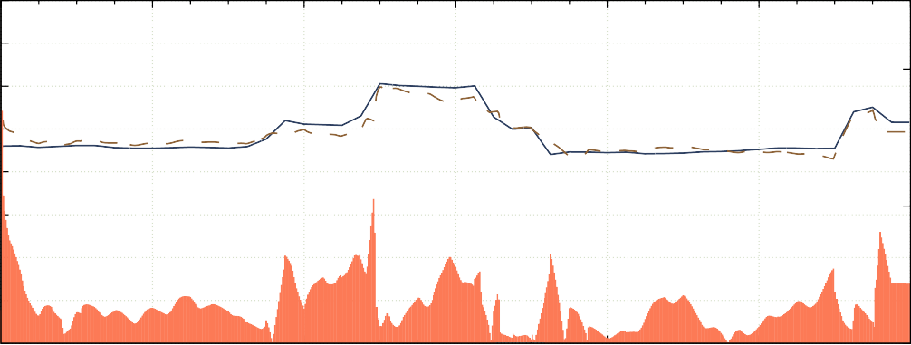

04:00

08:00

12:00

16:00

20:00

0

00:00

Time of Day

Power (*MW* )

in the network reduces power as less work is required from the compressors. Additionally, losses caused leaks, open valves, etc. are reduced. However, lowering the pressure set-point of the compressors requires independently controlling the air to the gold plant.

Using the verified simulation model, the compressor set-points were reduced to 420 *kPa*, the

10

5

10

%*error*

15

20

0

00:00

04:00

08:00

12:00

16:00

20:00

0

00:00

Baseline flow

Simulated flow

Error

Figure 4.4: The simulated flow compared to the actual measurement

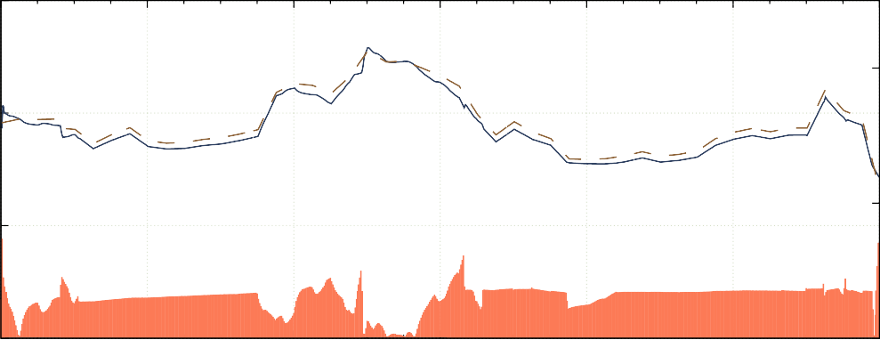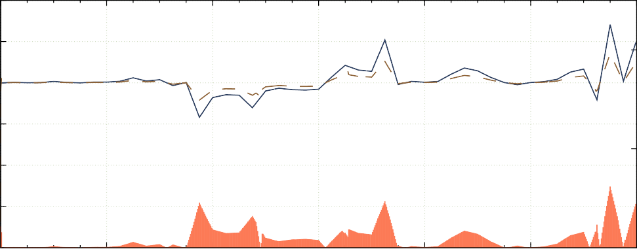

Time of Day

600

550

20

500

450

10

400

350

Pressure (*kPa*)

Flow (*kg/s*)

%*error*

300

00:00

04:00

08:00

12:00

16:00

20:00

0

00:00

Baseline press.

Simulated press.

Rel. Error

Figure 4.5: The simulated Pressure compared to the actual measurement

Time of Day

minimum allowed compressor set-point during the drilling shift. The compressor schedule was changed to allow independent control of the gold plant pressure. Gold plant pressure was maintained at 490 *kPa*.

The results of the simulation, shown, in fig. 4.6, indicated an average power reduction of

0.46 MW Peak-clip (P.C.). This energy optimisation relates to a R0.37 M Per annum (p.a) energy cost saving to the mine.

### Scenario 2. Control valves set points

An alternative scenario is to reduce the pressure at the control valves at each level. By reducing pressure at the control, set-points can be lowered to the minimum requirement per level. This can lead to higher savings than could be achieved through compressor set-points.



0

00:00

04:00

08:00

12:00

16:00

20:00

0

00:00

Figure 4.6: Energy savings by reducing compressor set-points

6

2

1*.*5

4

1

2

0*.*5

Baseline

Intervention

Time of Day

Power saving

Power (*MW* )

Power Saving (*MW* )

This scenario would be relatively easy to implement as it does not require any changes to the compressor control schedule.

Air pressure set-points were reduced to 300 kPa at the underground control valves during the evening peak period. Analysis of the simulation results showed a 1MW average P.C. saving. The intervention would lead to an annual cost saving of R0.91M.

6

2

1*.*5

4

1

2

0*.*5

Time of Day

Baseline

Scenario Power saving

Power (*MW* )

Power Saving (*MW* )

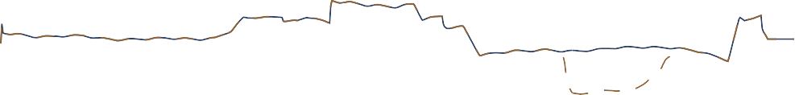

0

00:00

04:00

08:00

12:00

16:00

20:00

0

00:00

Figure 4.7: Power savings

### Comparison of scenario results

Comparing the scenarios in table 4.3 showed that Scenario 2 had a larger peak energy impact then scenario 1. Further savings could be achieved through a combination of the two scenarios as well as investigating set-point reductions during other periods of the day.

|  |  |  |
| --- | --- | --- |
| Scenario | Power saving | Cost saving p.a |
| **Scenario 1 results**  Reducing compressor set-points | 0*.*46 MW P.C. | R0.37M |

#### Scenario 2 results

Reducing underground pressure during evening peak 1*.*0 MW P.C. R0*.*91M

Table 4.3: Comparison of Mine A’s simulated scenarios

### Validation of results

Scenario 2 was implemented on the actual compressed air system. An energy saving of just under 1 MW P.C. was recorded when compared with the 2016 power baseline profile. These results matched the simulated scenario closely. fig. 4.8 shows the practical result compared with the simulated and baseline power profiles.

6

2

4

1*.*5

1

2

0*.*5

Power (*MW* )

Power Saving (*MW* )

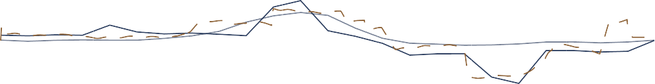

0

00:00

04:00

08:00

12:00

Time of Day

16:00

20:00

0

00:00

Baseline Actual

Simulation

Power saving

Figure 4.8: Actual power savings achieved on the system

### Summary

A case study was implemented on a mine compressed air network in the Freestate. Following the simulation methodology, An investigation was performed to gather data and identify potential interventions. A simulation model was developed to test scenarios. The tested interventions showed a P.C. saving of 1 MW which would result in a cost saving of R0.9M. The simulated was validated by implementation on the actual system leading to similar results.

## Case study 2: Simulated improvements on mine B

### System investigation

Case study B is large South African gold mine. The mine utilises five compressors sup- ply compressed air to various surface and underground operations. An investigation was performed to gather the data and information required to build a simulation model of the network. As well as to identify potential simulation scenarios.

A basic air distribution layout was developed for the system. **??** Illustrates the system process in detail, indicating the flow distribution to the three mining shafts and gold processing plant.

Data related to the mines scheduling as well as critical limits and set-points of the compressed air system was obtained from various mine personnel. From this a general understanding of the operation was obtained. Important data parameters such as Power, pressures and flows of the system were gathered from the SCADA as well other data measurement sources. This data will be used to develop and calibrate the simulation model

Strategic level investigations were performed on the significant mining levels to map and measure the locations and air usage for the cross-sections, refuge bays, major leaks and other compressed air consumers on each level. An example of a resultant schematic from the underground investigation is shown in fig. III.1. The information gathered from the system investigations was then utilised to develop and calibrate a simulation model.

Inlet air

Gold plant



Comp. 1

Comp. 2

Comp. 3 Comp. 4

Comp. 5

Main shaft

Sub Shaft

73L

76L

78L

80L

82L

85L

88L

92L

Online Standby Air flow Compressor

Control valve

Manual valve

95L

98L

102L

105L

190L

113L

29L

52L

66L

70L

71L

Figure 4.9: Process schematic of the compressed air network.

### Model development

Using the data obtained from the investigations on the network, a simulation model was developed in PTB. The methodology described in Chapter 3 was utilised in this process. The following assumptions made to simplify the model development:

* + - * After cooling reduced compressed air temperature from 60*o* Celcius to 40*o* Celcius
      * Underground temperature and humidity remained constant for each level

The boundaries of the baseline simulation were selected based on the available data for the network. The developed simulation model is shown in fig. I.2. For maximum accuracy, the simulation step size was set to the two minutes to match the resolution available from the data source. The model components was calibrated so that the simulated outputs matched data from the real system. The process flow diagram for the simulation is shown in fig. I.2. The model data inputs and outputs are described in table 4.1.

Inputs Outputs

Level measured flows Compressor powers

Compressor schedules Network flows

Set-points Network pressures

Table 4.4: Simulation inputs and outputs

#### Verification of baseline simulation

Using the verification methodology, the simulation model verified by comparing the simu- lation outputs to actual measured values. The compressors outlet pressure often does not match the set-point. To simplify the verification, the measured outlet pressure is temporar- ily used as set points for the compressors. This ensured that the pressure in the network is identical to that of the actual system as shown in fig. 4.10.

With the simulated pressure identical to the actual, the power and air flow outputs were compared with their relative actual values. fig. 4.11 shows the comparison of the total power and flow of the system with the actual measure values for that same period. The accuracy for these parameters compared to the real system was 98*.*7% and 99*.*0% respectively. This was within the acceptable error.

Once the power and flow parameters were verified with acceptable error, the actual pressure set-point profile was imported to the compressor controllers. The simulated outlet pressure was then compared to the actual measured pressure and set-point, this is shown in fig. 4.12.

%*error*

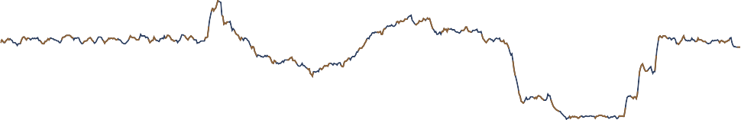

300

00:00

04:00

08:00

12:00

16:00

20:00

0

00:00

Figure 4.10: Comparing the pressure response of simulation to the actual measured pressure Verification method Result *Err*%

450

20

400

350

10

Baseline press.

Simulated press.

Time of Day

Rel. Error

Pressure (*kPa*)

#### Total Flow

|  |  |  |
| --- | --- | --- |
| Residual Difference | 0.22 kg/s | 0.53% |
| MAE | 0.43 kg/s error | 1.02% |
| Coefficient of determination | *r*2 = 0*.*99 | - |

**Total power**

|  |  |  |
| --- | --- | --- |
| Residual Difference | 0.05 MW | 0.39% |
| MAE | 0.16 MW error | 1.36% |
| Coefficient of determination | *r*2 = 0*.*91 | - |

|  |  |  |
| --- | --- | --- |
| **Compressor outlet pressure** |  | |
| Residual Difference | 2.79 kPa | 0.71% |
| MAE | 3.85 kPa error | 0.98% |
| Coefficient of determination | *r*2 = 0*.*890 | - |

Table 4.5: Verification of simulation model.

The accuracy of the compressor outlet pressure was acceptable at 99.02 %. To ensure the model accuracy, all measured flows and pressures were compared to the simulated outputs. This comparison is shown in table II.3.

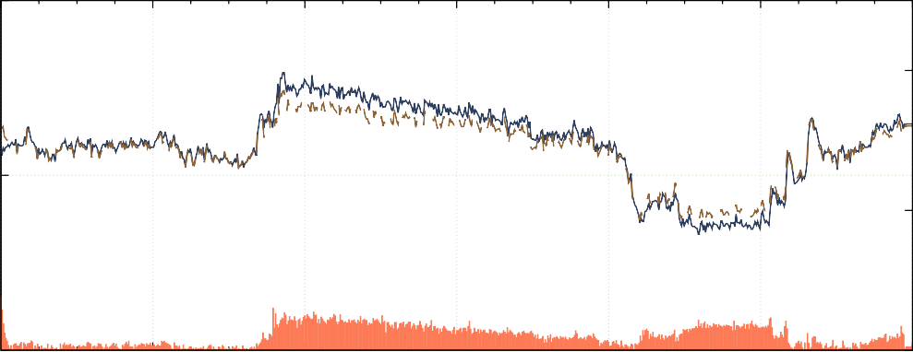

Time of Day

15

14

13

12

20

10

Power (*MW* )

flow (*kg/s*)

%*error*

%*error*

50

20

40

10

30

00:00

04:00

08:00

12:00

16:00

20:00

0

00:00

Baseline flow

Simulated flow

Rel. Error

(a)

Baseline power

Simulated power

Rel. Error

(b)

Figure 4.11: Verification of the total (a) flow and (b) power of the system using the actual pressure profile.

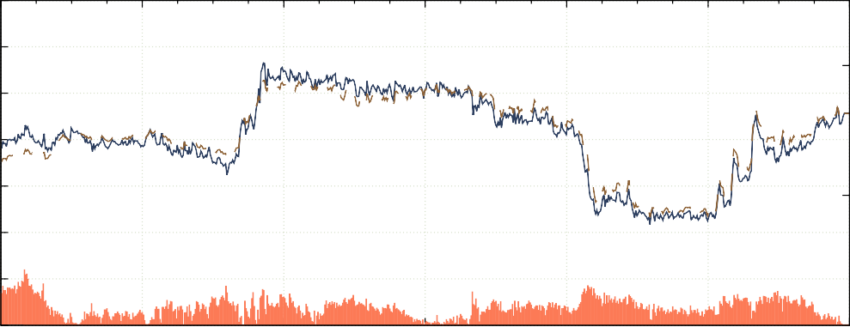

11

10

9

8

00:00

04:00

08:00

12:00

16:00

20:00

0

00:00

Time of Day

### Scenario 1. Refuge bay optimisation

From investigation, unnecessary refuge bay leaks were identified as a significant inefficiency that can be reduced. A test on a single mining level was performed to measure the potential flow saving of reducing refuge bay leaks. The test showed that by reducing refuge bay leaks, by closing the valves, would lead to an average air saving of 0*.*05 *kg/s* per refuge bay at typical operational pressures. This measurement was conservative as it was not possible to close all the refuge bays on the level for the test.

Due to the size of the mine, extending these tests to include the rest of the mining sections was not practical. Therefore, the benefits of an intervention on the entire mine could not

%*error*

300

00:00

04:00

08:00

12:00

Time of Day

16:00

20:00

0

00:00

Actual

Set-point

Rel. Error

Figure 4.12: Verifying the Pressure response of the system given the pressure set points as inputs

450

20

400

350

10

Simulation.

Pressure (*kPa*)

accurately be determined from practical tests. Using simulation the typical operation with can be accurately compare with the intervention scenario to quantify the potential financial and operational benefits throughout a given period.

The simulation model boundaries was updated to include refuge bay leaks on each level. For each refuge chamber, a air leak was added to the model by utilising per level layouts indicating locations of refuge bays. These leaks were modelled as flow demands using the data from the initial refuge bay tests. The overall mass flow of the system was maintained to ensure model accuracy. T By adding the flow component in the actual location in the process, the pressure to each chamber is correctly modelled. The full simulation model is shown in fig. I.7. The updated simulation model was re-checked to ensure accuracy. This model was used as a baseline to quantify saving for the scenario.

To create the optimised scenario, the refuge bay flow components were set to 0 *kg/s*. The simulation was performed and the output data compared ot the baseline. fig. 4.13 shows the baseline power compared to the optimised scenario. The comparison showed a potential

0.92 MW improvement in Energy efficiency (E.E.) through optimisation of refuge bay leaks. The optimised scenario would lead to a R5.13M energy cost saving for the mine.

An additional pressure benefit was identified during the drilling shift, shown in fig. 4.14. The reduced flow lead to a pressure increase of about 15 *kPa*. The pressure increase could lead to an increase in drilling efficiency.

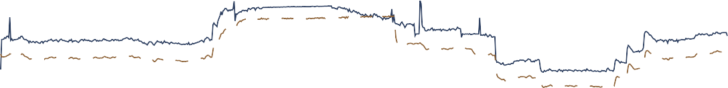

0

00:00

04:00

08:00

12:00

16:00

20:00

00:00

Figure 4.13: The Baseline system power compared to the system power when refuge bay leaks are reduced.

15

10

5

Baseline

Optimised

Time of Day

Power saving

440

420

400

380

Pressure (*kPa*)

Power (*MW* )

11 15 15 15 15 14 19 9 7

360

00:00

04:00

08:00

12:00

Time of Day

16:00

20:00

00:00

Baseline

Optimisation

Figure 4.14: The Baseline system pressure compared to the system pressure when refuge bay leaks are reduce.

### 4.3.4 Scenario 2. Closing off levels and inactive work areas

The largest impact on energy costs can be achieved during the energy peak times. At mine B, blasting coincides with the evening energy peak. Typically the air requirement during this period is lowered. However, due to the high prevalence of compressed air misuse, leaks and open valves, significant amounts of air is still used during these periods. Reducing pressure to areas during these times may lead to a major power and cost saving.

Closing off stope valves and reducing station pressure were identified as two strategies to reduce airflow during the evening peak. The station can not be closed completely as some services still require air supply.

In order to identify the most effective strategy, simulations were performed to quantify the effect of each on a single mining level. The level was modelled to include all major leaks, refuge bays and drilling sections.

The components of the modelled were calibrated using manual measurements from an in- vestigation of the level. The simulation schematic for is shown in the simulation diagram shown in fig. 4.15. The results of the single level simulation can be expanded to other levels to obtain the total potential improvement that can be achieved.

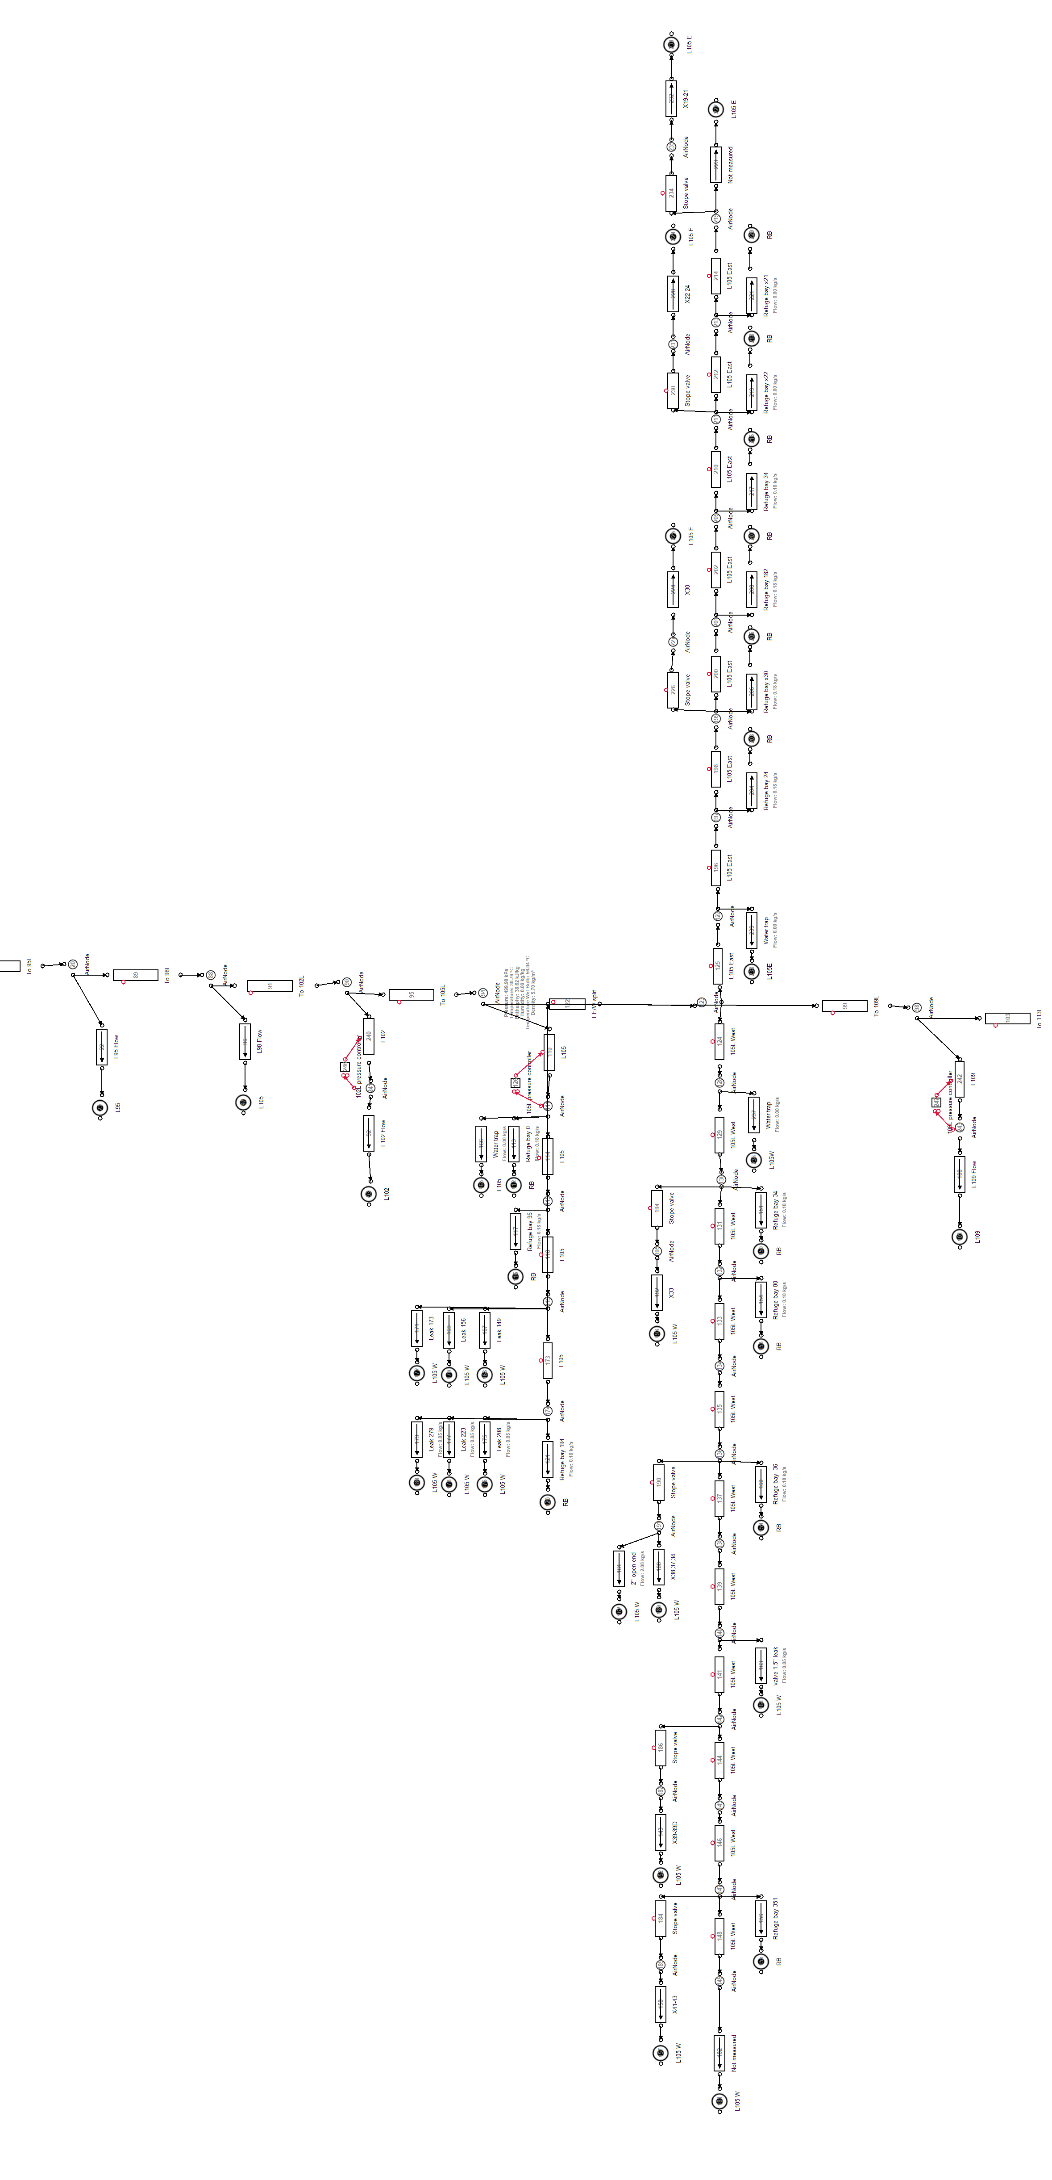

Figure 4.15: Underground level layout.

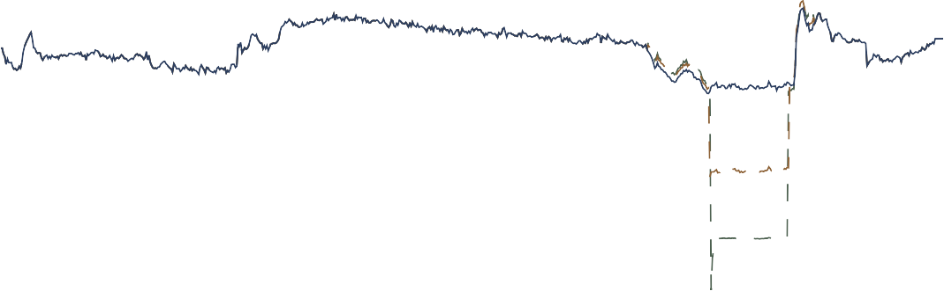Station control, in-stope control and a combination were simulated were all simulated for 105L. Station control means control of the pressure of at the station of the level. In-stope control is control of the is cut the airflow to the mining section during certain periods. fig. 4.16 shows the effect the various interventions have on the flow for 105L compared to the baseline.

4*.*5

4

3*.*5

3

2*.*5

2

1*.*5

1

0*.*5

0

00:00

04:00

08:00

12:00

16:00

20:00

00:00

Station control

In-stope control

Time of Day

Baseline

Flow (*kg/s*)

|  |  |  |  |  |  |
| --- | --- | --- | --- | --- | --- |
|  |  |  |  |  |  |
|  |  |  |  |  |  |
|  |  |  |  |  |  |
|  |  |  |  |  |  |
|  |  |  |  |  |  |
|  |  |  |  |  |  |
|  |  |  |  |  |  |
|  |  |  |  |  |  |
|  |  |  |  |  |  |

Figure 4.16: Flow reduction during blasting period for 105 level

Station control had the largest impact on the flow usage for the level. This reflects with the power reduction achieved for each intervention shown in fig. 4.17. The impact was 0.4 and

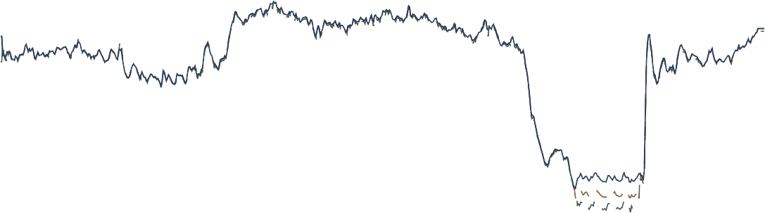0.7 MW for the stope and station intervention respectively.

Power (*MW* )

|  |  |  |  |  |  |
| --- | --- | --- | --- | --- | --- |
|  |  |  |  |  |  |
|  |  |  |  |  |  |
|  |  |  |  |  |  |
|  |  |  |  |  |  |

Figure 4.17: Comparing simulated flow interventions on 105L.

14

12

10

8

00:00

04:00

08:00

12:00

16:00

20:00

00:00

Station control

In-stope control

Time of Day

Baseline

A simulation was done to estimate the potential savings of extending the evening station control to other levels. This was performed by updating the flow demands for levels 95- 115 to match the flow saving achieved in the 105L simulation. The savings achieved for the

general station control were 2.0 MW P.C., shown in fig. 4.18. It was calculated that this would lead to a annual energy cost saving of R2.5M.

12

8

4

Power (*MW* )

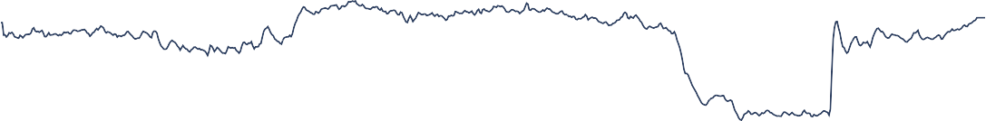

0

00:00

04:00

08:00

12:00

Time of Day Power Savings

16:00

20:00

00:00

Intervention

Baseline

Figure 4.18: Energy saving achieved by general peak time Station control

### Comparison of interventions

The interventions were then compared for feedback to the mine. The refuge bay intervention is recommended as it will achieve the highest energy cost saving. These results were used to produce a report that was sent to the responsible personnel at Mine B.

Scenario Power saving

|  |  |  |  |
| --- | --- | --- | --- |
|  | | (p.a) |  |
| **Scenario 1 results** |  |  |
| Refuge bay leakage reduction | 0*.*92 MW E.E. | R5.17M | Increase in drilling pressure |
| **Scenario 2 results** |  |  |  |
| 105L peak time in-Stope control | 0*.*4 MW P.C. | R0*.*3M | - |
| 105L peak time Station control | 0*.*7 MW P.C. | R2*.*5M | - |
| General peak time Station control | 2*.*0 MW P.C. | R2*.*5M | - |

Cost saving

Additional benefit

Table 4.6: Comparison of the simulated scenarios

### Summary

A second case study was implemented on a mine compressed air network. An investigation was performed to gather data and identify potential interventions. This included under-

ground spot checks and measurements.

A simulation model was developed to test scenarios. Two scenarios (refuge bay optimisations and per level flow optimisations) were simulated. The simulated interventions showed a E.E. saving of up to 0.92 MW which would result in a cost saving of R5.17M with an additional pressure improvement for scenario 1. The results for scenario 2 showed a P.C. impact of up to 2 MW with an annual energy cost saving of R2.5M. The results of the simulations were reported to the mine.

## Case study 3: Periodic simulation analysis

### Preamble

Updating the inputs of a simulation periodically could be used to verify simulation model accuracy. If the precision of simulation outputs remains for subsequent days, this would indicate that the model is correctly calibrated. Additionally, this process could be used to identify significant operational changes that occur within the system. This would cause the simulation outputs to differ from the actual measured parameters.

A daily periodic simulation analysis was implemented between 2016/11/01 and 2016/11/30 using the periodic simulation methodology discussed in Chapter 3. The simulation model developed for case study A was used for the analysis. The simulation receives the data inputs shown in table 4.7.

Inputs Outputs

Ambient air conditions Compressor power Measured flows Flows

Compressor schedules Pressures

Table 4.7: Data inputs and outputs for the simulation

### Results

The process was triggered daily. For each period, data inputs shown in table 4.7 were imported into the model, the simulation was then processed and the outputs are compared with the real system parameters. fig. 4.19 shows the average daily accuracy of the simulated total system power, flow and the shaft pressure per period.

The accuracy of the process parameters of the simulation was within 5% for the duration

|  |  |  |  |  |
| --- | --- | --- | --- | --- |
|  |  |  |  |  |
|  |  |  |  |  |
|  |  |  |  |  |
|  |  |  |  |  |

Figure 4.19: The flow, pressure and power error percentages for daily periodic simulations over a month.

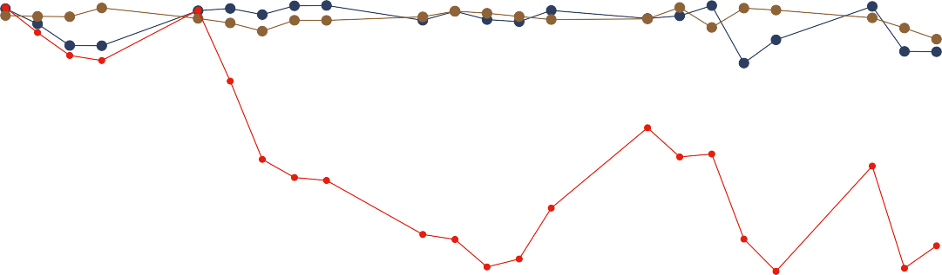

100

95

90

85

80

2016/11/01

2016/11/07

2016/11/13

2016/11/19

2016/11/25

Date of simulation

Flow Pressure Power

Accuracy (%)

of the periodic simulation. However, From the 2016/11/07, the accuracy of the simulated power dropped by between 10 and 15 percent. The daily average power of the system up to the point was approximately 12.5 MW, a 15% simulation error therefore relates to 1.9 MW difference between simulated and actual parameters. This suggests a major shift in operation of the system.

An analysis was done to try determine the source of the discrepancy. From the data it was identified that the simulated power for compressor 1 was the source of the different A look at the actual power measurement for compressor 1 show drop compared to normal operation by almost 2 MW. At the same time the power used per kg/s of air seemed to have dropped. fig. 4.20 shows the average daily power for compressor 1 (blue), compared to the air mass flow per Watt(yellow).

As a 2 MW shift in power is not likely, the results seem to show that there was a fault in the power metering starting from 2016/11/07. This explains the perceived increase in efficiency over the same period as a less power is measure then is actually being provided. In this situation the simulated power measurement is actually a more accurate metric for compressor 1’s power over this period.

### Validation

To validation of misreadings from the power meter from comparing independent power data for the substation to the combined individual compressors meters.fig. 4.21 shows the mea- sured power from the two sources. By comparing the compressor power to the independent

Figure 4.20: Supply efficiency and Compressor 1’s average power output over the time of the periodic analysis.



Periodic simulation

1000

2016/09/01

2016/10/01

2016/11/01

Date

2016/12/01

Compressor 1 average power System efficiency

4000

5

3500

4*.*5

3000

4

2500

3*.*5

2000

3

1500

2*.*5

2

Power (kW)

*FlowperWatt*(*kg/s/W* )

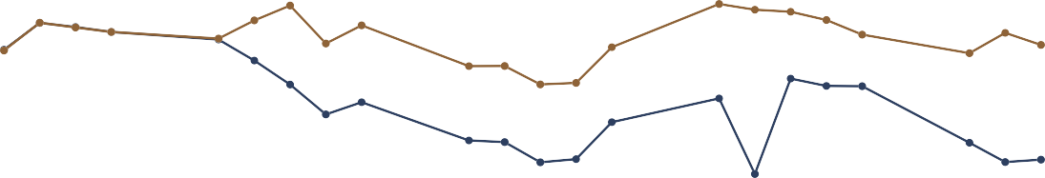data, it is clear that there is an error in measurement as hypothesised.

Power (MW)

|  |  |  |  |  |  |
| --- | --- | --- | --- | --- | --- |
|  |  |  |  |  |  |
|  |  |  |  |  |  |
|  |  |  |  |  |  |
|  |  |  |  |  |  |

Figure 4.21: Comparison using alternative power source.

14

12

10

8

05/11/2016 10/11/2016 15/11/2016 20/11/2016 25/11/2016 30/11/2016

Date

Compressor power measrement Independant measurement

### Summary

An investigation into periodic or repeated simulation was performed. Using the simulation model for Mine B, the periodic simulation methodology was implemented. The results indicated that the model was valid for sequential days in the test range and identified an error in power measurement. Further analysis is recommended to identify how long a simulation model can remain valid before calibration is required.

## Potential benefit for SA mines

There are proximately 75 operational gold and Platinum group metal (PGM) mines in South Africa, as illustrated in fig. 4.22 1*,*2. Each mine utilises compressed air for underground processes. By utilising the compressed air simulation methodology in this study, the mines could collectively achieve significant energy and cost savings for the industry.

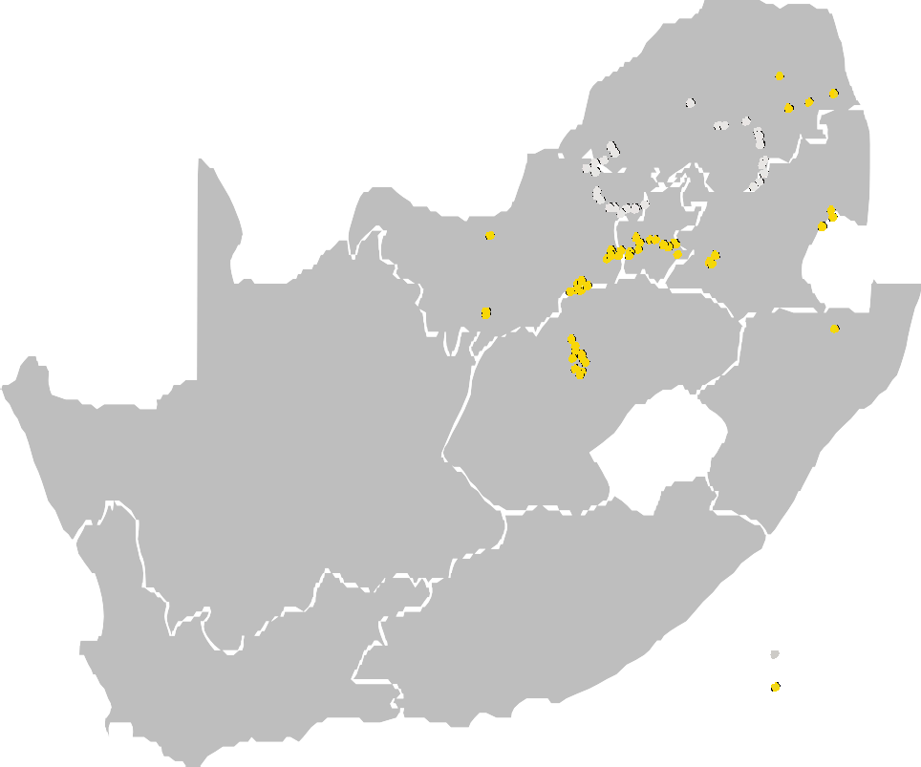

PGM mines Gold mines

Figure 4.22: Gold and PGM mines in South Africa1*,*2.

In this study, the simulated interventions resulted in savings of (on average) 0.69 MW E.E. or 1.025 *MW* P.C.. Assuming similar intervention were identified, through simulation for all gold and platinum mines. A potential energy saving of approximately 50 MW E.E. or 75 *MW* P.C. could be achieved. The combined cost saving for these interventions would amount to up to R400M p.a.

1 Chamber of Mines, [Online] <http://www.chamberofmines.org.za/sa-mining/gold>, [Accessed 16-06- 2017]

2 Chamber of Mines, [Online] <http://www.chamberofmines.org.za/sa-mining/platinum>, [Accessed 16- 06-2017]

## Conclusion

Chapter 4 aimed to validate the methodology developed in Chapter 3. This was achieved through the implementation on two case studies South African gold mines. A third case study was performed to analyse and validate the the value repeated/periodic simulation.

In case study 1, the compressed air network for gold mining complex consisting of three mining shafts was investigated. A simulation model was then developed and the accuracy was verified using typical operation from historical data. Two scenarios were simulated, Optimising compressor set-points and reducing pressure during the evening energy peak.

The results showed that there was a potential P.C. power reduction of 0.46 and 1.0 MW respectively. This could lead to a potential cost reduction of up to R0.91M. The result was validated using results of actual tests on the system.

In case study 2, the same procedure was applied to another gold mine. The mine consisted of a main and sub-shaft. An investigation was done to gather data and identify potential interventions. This included underground spot checks and measurements.

A simulation model was developed for the system. Using the model, two scenarios were simulated. The simulations showed an E.E. saving of up to 0.92 MW for scenario 1 and a

P.C. impact of up to 2 MW for scenario 2. The intervention could lead to an energy cost saving of R5.17M for the mine. Additional pressure improvements were identified in case study 1. The results were reported to the mine.

A third case study was performed to validate the periodic or repeated simulation methodol- ogy. The results showed that the simulation model remained valid for sequential days in the tested date range. Faulty power measurements were also identified from the results. Further analysis was recommended to identify how long a simulation model can remain valid before calibration is required.

Finally the the result of large scale implementation of compressed air simulation in South African gold and PGM mines. A conservative estimation showed that a potential power reduction of 50 MW E.E. or 75 *MW* P.C. could be obtained. This would lead to a significant total energy cost saving of R400M p.a.

## CHAPTER 5

**Conclusion**

## Preamble

Chapter 5 serves as a conclusion for this dissertation. An overview of the complete dis- sertation will be provided. This overview will summarise the work done in the proceeding chapters. The limitations of the study will then be discussed. This will lead to discussion and recommendations for future work that can be done in the field.

## Dissertation overview

The South African mining sector is currently facing significant challenges that pose a risk to profitability of the industry. A pivotal challenge that faces the industry is that of rising operational costs. Energy costs pertain a significant portion of the cost increases as energy tariff increases have constantly surpassed inflation over the passed 10 years.

Compressed air systems consume the largest portion of energy used in a mine. Compressed air has also been shown to be largely inefficient. It is there for reasoned that the largest energy impact can be achieved through compressed air interventions.

Energy intervention in mining compressed air have been performed in the passed. However, compressed air simulation has not been used to its full potential. Using new computer mod- elling and simulation tools for compressed air systems, the detailed effects of interventions can be identified with minimal risk. This will lead to further energy and cost reductions as well as other potential improvements for a mines operation.

An review of background and literature was performed. The purpose of the review was to provide background on mining compressed air networks and to evaluate literature in pertaining to compressed air energy interventions, simulation usage the mining industry and specifically simulation usage in compressed air systems.

Using the findings in from the literature review, a methodology was developed for compressed air simulation. The methodology describes the a simulation procedure in three steps sum- marised as: investigate the system, develop a simulation model and execute the simulation scenarios.

The simulation methodology was then validated through implementationon case studies. The studies were implemented on two separate mine compressed air systems. A full system investigation was performed in each study. From the data and understand obtained for the

investigation, simulation models were developed for both systems.

*...Incomplete....*

## Limits of this study

## Recommendations for future studies

## Bibliography

* + 1. P. Neingo and T. Tholana, “Trends in productivity in the south african gold mining industry,” *Journal of the Southern African Institute of Mining and Metallurgy*, vol. 116, no. 3, pp. 283–290, 2016.
    2. Eskom, “Revenue application - multi year price determination 2013/14 to 2017/18 (mypd3),” [Online] [http://www.eskom.co.za/CustomerCare/MYPD3/Documents/](http://www.eskom.co.za/CustomerCare/MYPD3/Documents/NersaReasonsforDecision.pdf) [NersaReasonsforDecision.pdf](http://www.eskom.co.za/CustomerCare/MYPD3/Documents/NersaReasonsforDecision.pdf), 2013, [Accessed 22 March 2017].
    3. G. M. Mudd, “Global trends in gold mining: Towards quantifying environmental and resource sustainability,” *Resources Policy*, vol. 32, no. 1, pp. 42–56, 2007.
    4. J. Mu¨ller and H. Frimmel, “Numerical analysis of historic gold production cycles and implications for future sub-cycles,” *The Open Geology Journal*, vol. 4, no. 1, pp. 29–34, 2010.
    5. J. Vosloo, L. Liebenberg, and D. Velleman, “Case study: Energy savings for a deep-mine water reticulation system,” *Applied Energy*, vol. 92, pp. 328–335, 2012.
    6. Eskom Demand Side Management Department, “The energy efficiency series - to- wards an energy efficient mining sector,” [Online] [http://www.eskom.co.za/sites/idm/](http://www.eskom.co.za/sites/idm/Documents/121040ESKD_Mining_Brochure_paths.pdf) [Documents/121040ESKD Mining Brochure paths.pdf](http://www.eskom.co.za/sites/idm/Documents/121040ESKD_Mining_Brochure_paths.pdf), February 2010, [Accessed 19 March 2017].
    7. H. Le Roux, “Energy consumption reduction challenge,” *Mining Weekly, PO Box*, vol. 75316, p. 30, 2005.
    8. J. Marais, “An integrated approach to optimise energy consumption of mine compressed air systems,” Ph.D. thesis, North-West University, 2012.
    9. L. Padachi *et al.*, “Energy efficiency through the integration of compressed air supply control with air network demand control,” in *Proceedings of the Industrial and Com- mercial Use of Energy Conference (ICUE)*. Citeseer, 2009, pp. 77–80.
    10. J. Du Plessis and R. Pelzer, “Development of an intelligent control system for mine compressor systems,” in *Proceedings of the Industrial and Commercial Use of Energy Conference (ICUE)*. IEEE, 2011, pp. 59–63.
    11. J. Neale and P. Kamp, “Compressed air system best practice programmes: What needs to change to secure long-term energy savings for new zealand?” *Energy Policy*, vol. 37, no. 9, pp. 3400–3408, 2009.
    12. Marais *et al.*, “Simplification of mine compressed air systems,” in *Proceedings of the Industrial and Commercial Use of Energy Conference (ICUE)*. IEEE, 2013, pp. 1–8.
    13. L. B. N. Laboratory, *Improving Compressed Air System Performance: A Sourcebook for Industry*, 2nd ed. Washington DC: US Department of Energy, 2004.
    14. A. van Tonder, “Sustaining compressed air dsm project savings using an air leakage management system,” Masters dissertation, North-West University, 2011.
    15. J. Snyman, “Integrating various energy saving initiatives on compressed air systems of typical south african gold mines,” Masters dissertation, North-West University, 2010.
    16. Kocsis *et al.*, “The integration of mine simulation and ventilation simulation to develop a ‘life cycle’ mine ventilation system,” *Application of Computers and Operations Research in the Minerals Industries, South African Institute of Mining and Metallurgy*, pp. 223– 230, 2003.
    17. J. Banks, *Handbook of simulation: principles, methodology, advances, applications, and practice*. John Wiley & Sons, 1998.
    18. J. Bredenkamp, A. Schutte, and J. F. van Rensburg, “Challenges faced during imple- mentation of a compressed air energy savings project on a gold mine,” in *Proceedings of the 12th Industrial and Commercial Use of Energy Conference (ICUE)*. IEEE, 2015.
    19. P. Mar´e, J. Bredenkamp, and J. Marais, “Evaluating compressed air operational im- provements on a deep-level mine through simulations,” in *Proceedings of the Industrial and Commercial Use of Energy Conference (ICUE)*. IEEE, 2017.
    20. S. Fouch´e, “Improving efficiency of a mine compressed air system,” Masters dissertation, North-West University, 2016.
    21. W. Booysen, “Reducing energy on rsa mines through optimised compressor control,” Masters dissertation, North-West University, 2010.
    22. M. Yang, “Air compressor efficiency in a vietnamese enterprise,” *Energy Policy*, vol. 37, no. 6, pp. 2327–2337, 2009.
    23. A. van Jaarsveld, S. Ebben, and A. Ashanti, “Development and implementation of an electrically powered stope rockdrill for tau tona mine,” in *SAIMM Narrow Vein and Reef Conference, Sun City, South Africa*, 2008.
    24. P. Fraser, “Saving energy by replacing compressed air with localized hydropower sys- tems: a ‘half level’model approach,” *Platinum in Transformation*, 2008.
    25. D. Brake and G. Bates, “Criteria for the design of emergency refuge stations for an underground metal mine,” in *AusIMM Proceedings*, vol. 304, no. 2. The Australian Institute of Mining and Metallurgy, 1999, pp. 1–8.
    26. C. Kriel, “Modernising underground compressed air dsm projects to reduce operating costs,” Masters dissertation, North-West University, 2014.
    27. F. Schroeder, “Energy efficiency opportunities in mine compressed air systems,” Masters dissertation, North-West University, 2009.
    28. J. Marais and M. Kleingeld, “An expert control system to achieve energy savings on mine compressed air systems,” *Industrial and commersial use of energy (ICUE)*, 2010.
    29. W. Booysen *et al.*, “Optimising compressor control strategies for maximum energy sav- ings,” *Proceedings of the Industrial and Commercial Use of Energy Conference (ICUE)*, pp. 10–12, 2009.
    30. R. Saidur *et al.*, “A review on compressed-air energy use and energy savings,” *Renewable and Sustainable Energy Reviews*, vol. 14, no. 4, pp. 1135 – 1153, 2010.
    31. J. Bredenkamp, “Reconfiguring mining compressed air networks for cost savings,” Mas- ters dissertation, North-West University, 2013.
    32. A. J. M. Van Tonder, “Sustaining compressed air dsm project savings using an air leakage management system,” in *Proceedings of the Industrial and Commercial Use of Energy Conference (ICUE)*. IEEE, 2011, pp. 133–137.
    33. B. Pascoe, “Improving mine compressed air network efficiency through demand and supply control,” Masters dissertation, North-West University, 2016.
    34. J. Marais, M. Kleingeld, and R. Pelzer, “Increased energy savings through a compressed air leakage documentation system,” *ICUE, SA*, vol. 11, 2009.
    35. M. Kleingeld and J. Marais, “A high level strategy plan for reducing a mine group’s de- pendence on compressed air,” *Proc. Industrial and Commercial Use of Energy (ICUE), Cape Peninsula University of Technology*, 2010.
    36. Bester *et al.*, “The effect of compressed air pressure on mining production and energy demand,” in *Proceedings of the Industrial and Commercial Use of Energy Conference (ICUE)*. IEEE, 2013, pp. 1–4.
    37. C. Cilliers, “Benchmarking electricity use of deep-level mines,” Ph.D. thesis, North-West University, 2015.
    38. van Niekerk *et al.*, “The value of simulation models when implementing mine dsm projects,” in *Proceedings of the Industrial and Commercial Use of Energy Conference (ICUE)*. IEEE, 2013, pp. 1–4.
    39. W. van Niekerk, “The value of simulation models for mine dsm projects,” Masters dissertation, North-West University, 2012.
    40. A. Holman, “Benefits of improved performance monitoring of mine cooling systems,” Masters dissertation, North-West University, 2014.
    41. P. Mar´e, “Novel simulations for energy management of mine cooling systems,” Ph.D. thesis, North-West University, 2016.
    42. W. Bouwer, “Designing a dynamic thermal and energy system simulation scheme for cross industry applications,” Ph.D. thesis, North-West University, 2004.
    43. S. W. Van Heerden, R. Pelzer, and J. Marais, “Developing a dynamic control system for mine compressed air networks,” in *Proceedings of the Industrial and Commercial Use of Energy Conference (ICUE)*. IEEE, 2014, pp. 1–8.
    44. Y. Hollander and R. Liu, “Estimation of the distribution of travel times by repeated simulation,” *Transportation Research Part C*, vol. 16, pp. 212–231, 2008.
    45. A. van Tonder, “Automation of compressor networks through a dynamic control sys- tem,” Ph.D. thesis, North-West University, 2014.
    46. H. Sarin, M. Kokkolaras, G. Hulbert, P. Papalambros, S. Barbat, and R.-J. Yang, “Comparing time histories for validation of simulation models: error measures and metrics,” *Journal of dynamic systems, measurement, and control*, vol. 132, no. 6, p. 061401, 2010.
    47. Y.-j. Xu, S.-j. Zhang, and Y.-h. Xiao, “Modeling the dynamic simulation and control of a single effect libr–h 2 o absorption chiller,” *Applied Thermal Engineering*, vol. 107, pp. 1183–1191, 2016.
    48. Kurnia *et al.*, “Simulation of a novel intermittent ventilation system for underground mines,” *Tunnelling and Underground Space Technology*, vol. 42, pp. 206–215, 2014.
    49. J. C. Kurnia, A. P. Sasmito, and A. S. Mujumdar, “Dust dispersion and management in underground mining faces,” *International Journal of Mining Science and Technology*, vol. 24, no. 1, pp. 39–44, 2014.
    50. D. C. Arndt, “Integrated dynamic simulation of large thermal systems,” Ph.D. thesis, University of Pretoria, 2000.
    51. M. Sprague and T. Geers, “Objective error measure for the comparison of calculated and measured transient response histories,” *Shock and Vibration Bulletin*, pp. 99–107, 1984.
    52. ——, “Spectral-element method for modelling cavitation in transient fluid-structure interaction,” *Int. J. Numer. Methods Eng.*, pp. 2467—-2499, 2004.
    53. D. Russell, “Error measures for comparing transient data: Part i, development of a comprehensive error measure,” *Proceedings of the 68th Shock and Vibration Symposium*, 1997.
    54. ——, “Error measures for comparing transient data: Part ii, error measures case study,” proceedings of the 68th shock and vibration,” *Proceedings of the 68th Shock and Vibra- tion Symposium*, pp. 212–231, 1997.
    55. C. J. Willmott and K. Matsuura, “Advantages of the mean absolute error (mae) over the root mean square error (rmse) in assessing average model performance,” *Climate research*, vol. 30, no. 1, pp. 79–82, 2005.
    56. S. Dominic and Maier, “Dynamic modeling and simulation of compressor trains for an air separation unit,” *IFAC Proceedings Volumes*, vol. 47, no. 3, pp. 432–437, 2014.
    57. D. Plessis *et al.*, “The development and integrated simulation of a variable water flow energy saving strategy for deep-mine cooling systems,” *Sustainable Energy Technologies and Assessments*, vol. 10, pp. 71–78, 2015.
    58. P. Peach, “Optimising deep-level mine refrigeration control for sustainable cost savings,” Masters dissertation, North-West University, 2016.
    59. A. Gous, W. Booysen, and W. Hamer, “Data quality evaluation for measurement and verification processes,” in *Proceedings of the Industrial and Commercial Use of Energy Conference (ICUE)*. IEEE, 2016, pp. 9–15.
    60. L. Meijsen, J. van Rensburg, and W. Booysen, “Verification procedures to ensure consis- tent energy metering,” in *Proceedings of the Industrial and Commercial Use of Energy Conference (ICUE)*. IEEE, 2015, pp. 138–146.
    61. S. V. Niekerk, “Quantification of energy consumption and production drivers in steel manufacturing plants,” Masters dissertation, North-West University, 2016.
    62. H. J. V. Rensburg, “Structuring mining data for rsa section 12l ee tax incentives,” Masters dissertation, North-West University, 2016.
    63. G. Heyns, “Challenges faced during implementation of a compressed air energy savings project on a gold mine,” Masters dissertation, North-West University, 2014.
    64. M. H. P. Van Niekerk, S. van Heerden, and J. van Rensburg, “The implementation of a dynamic air compressor selector system in mines,” in *Proceedings of the Industrial and Commercial Use of Energy Conference (ICUE)*. IEEE, 2015, pp. 129–132.

## APPENDIX I

**Simulation process flow schematics**

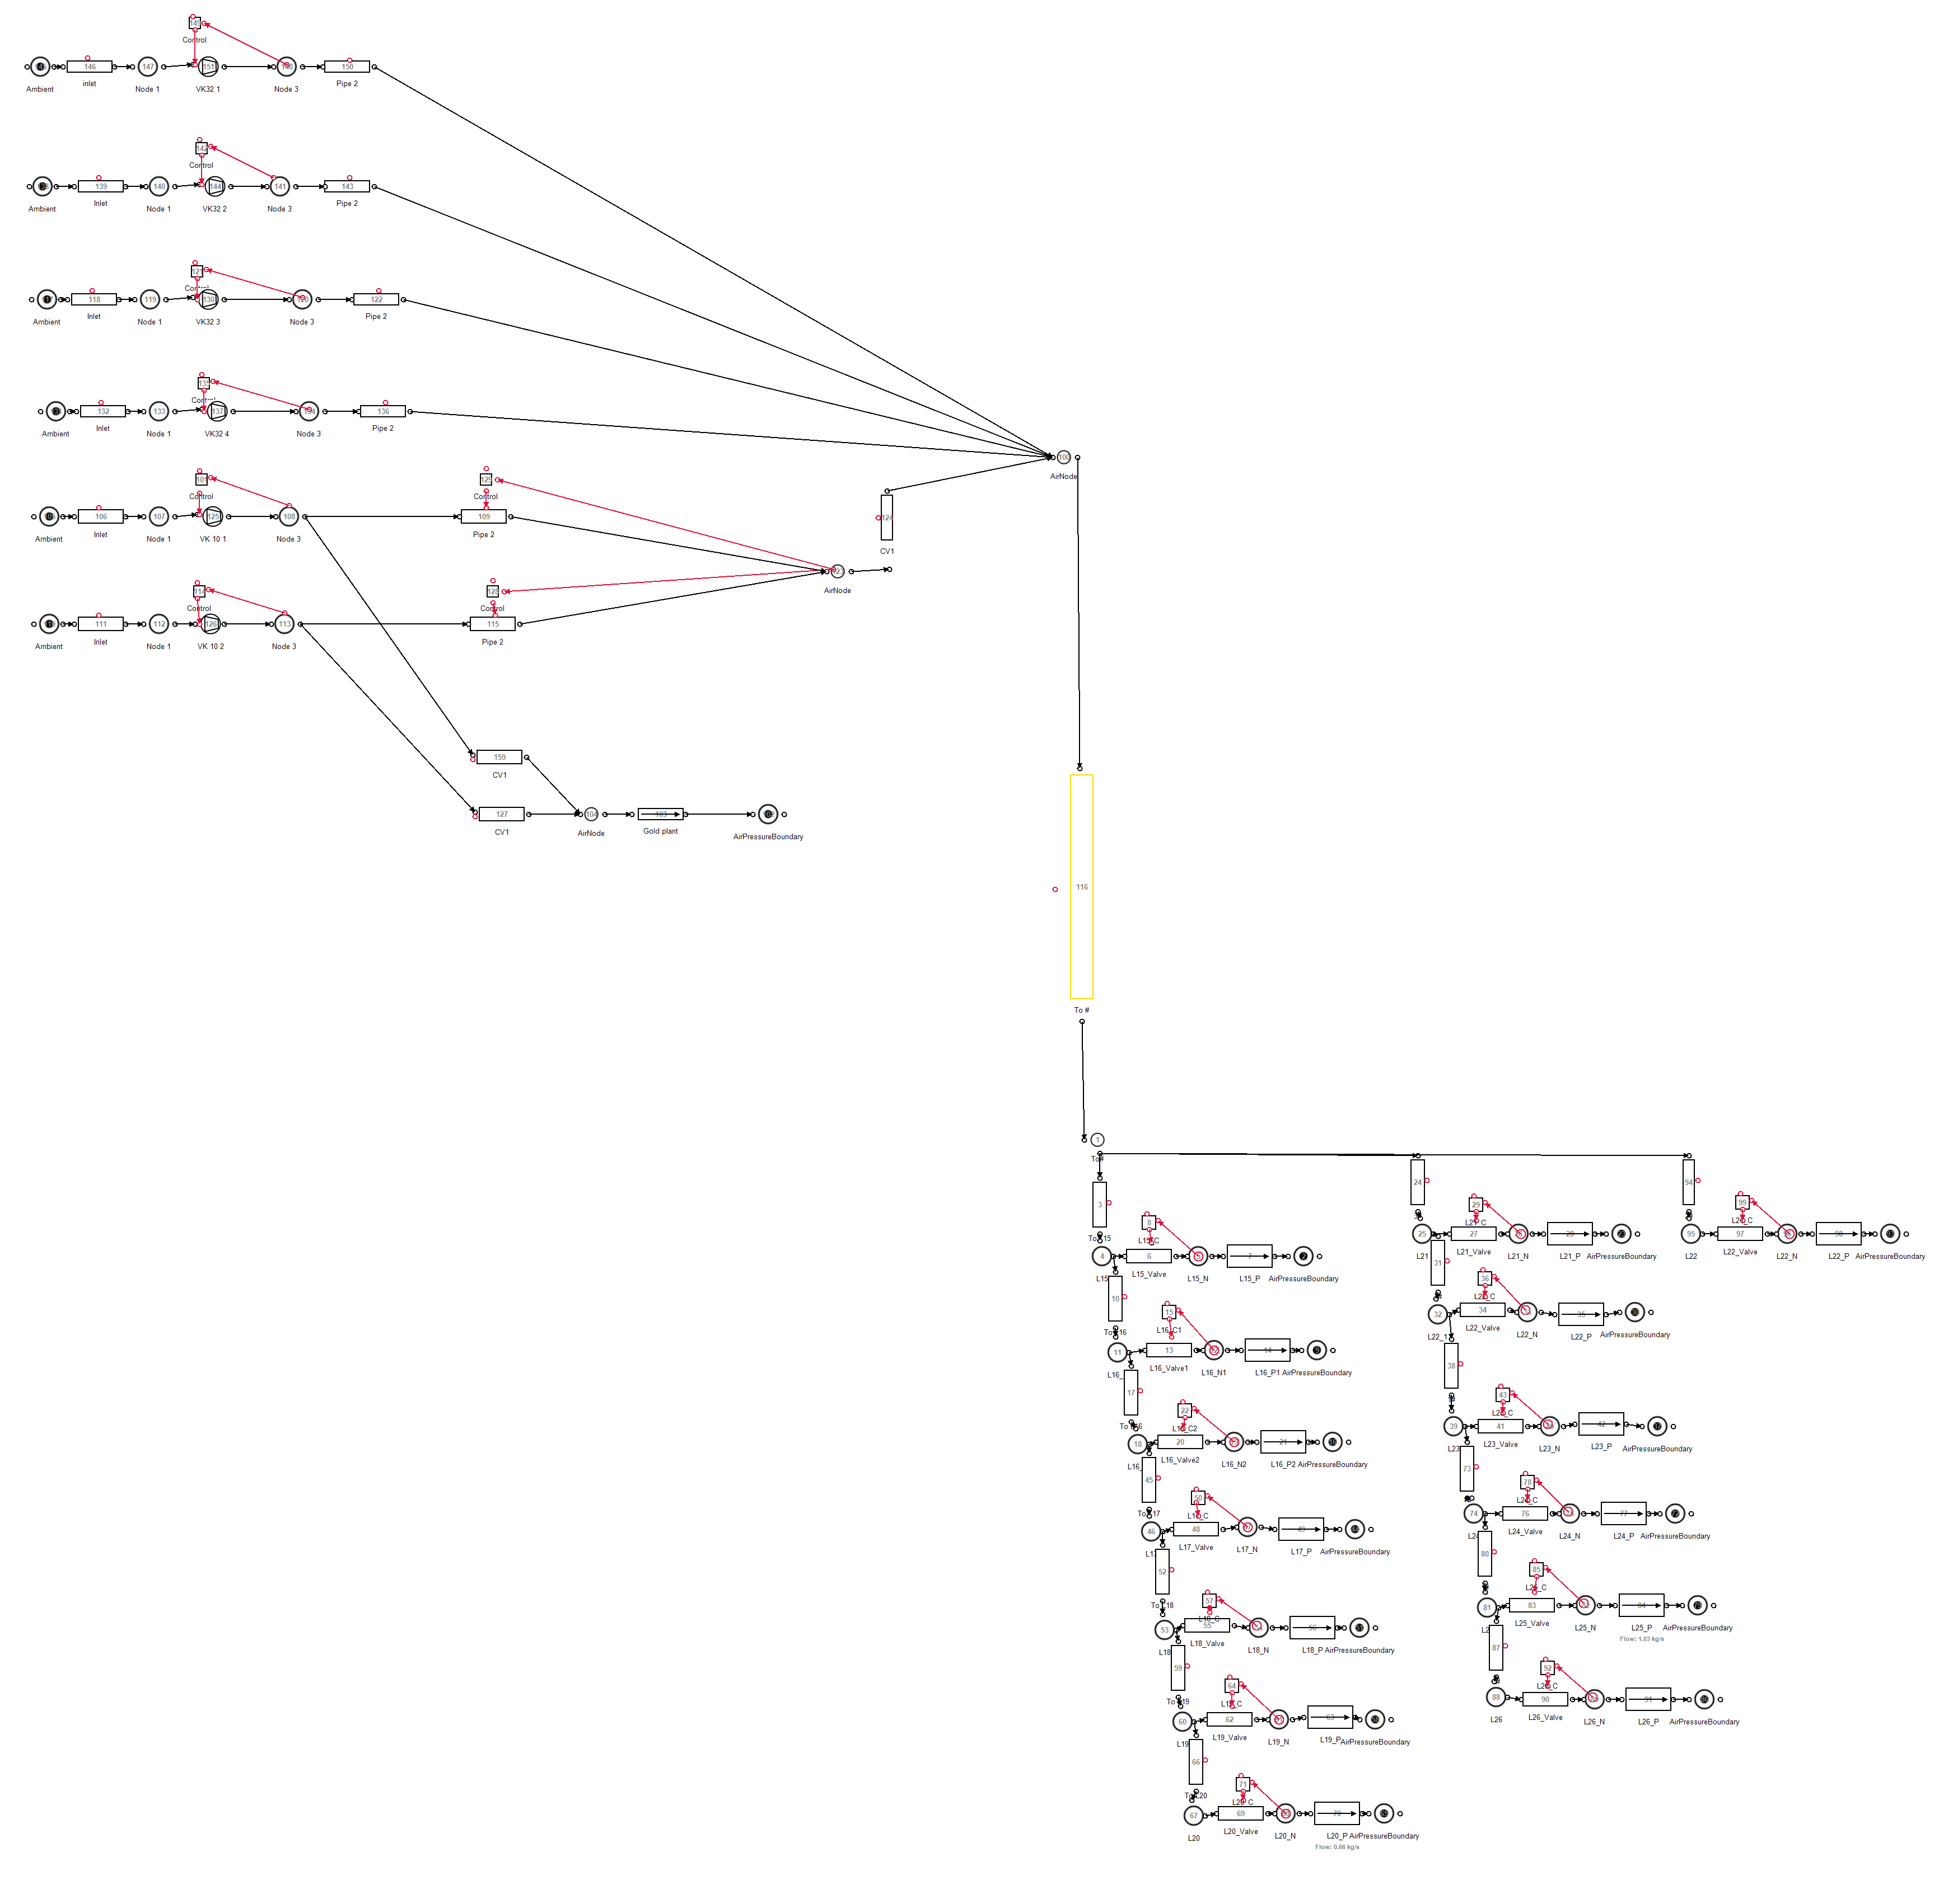

Compressors

Gold plant

Underground air

users

1# 3# 2#

Figure I.1: Mine A: Simulation process flow schematic

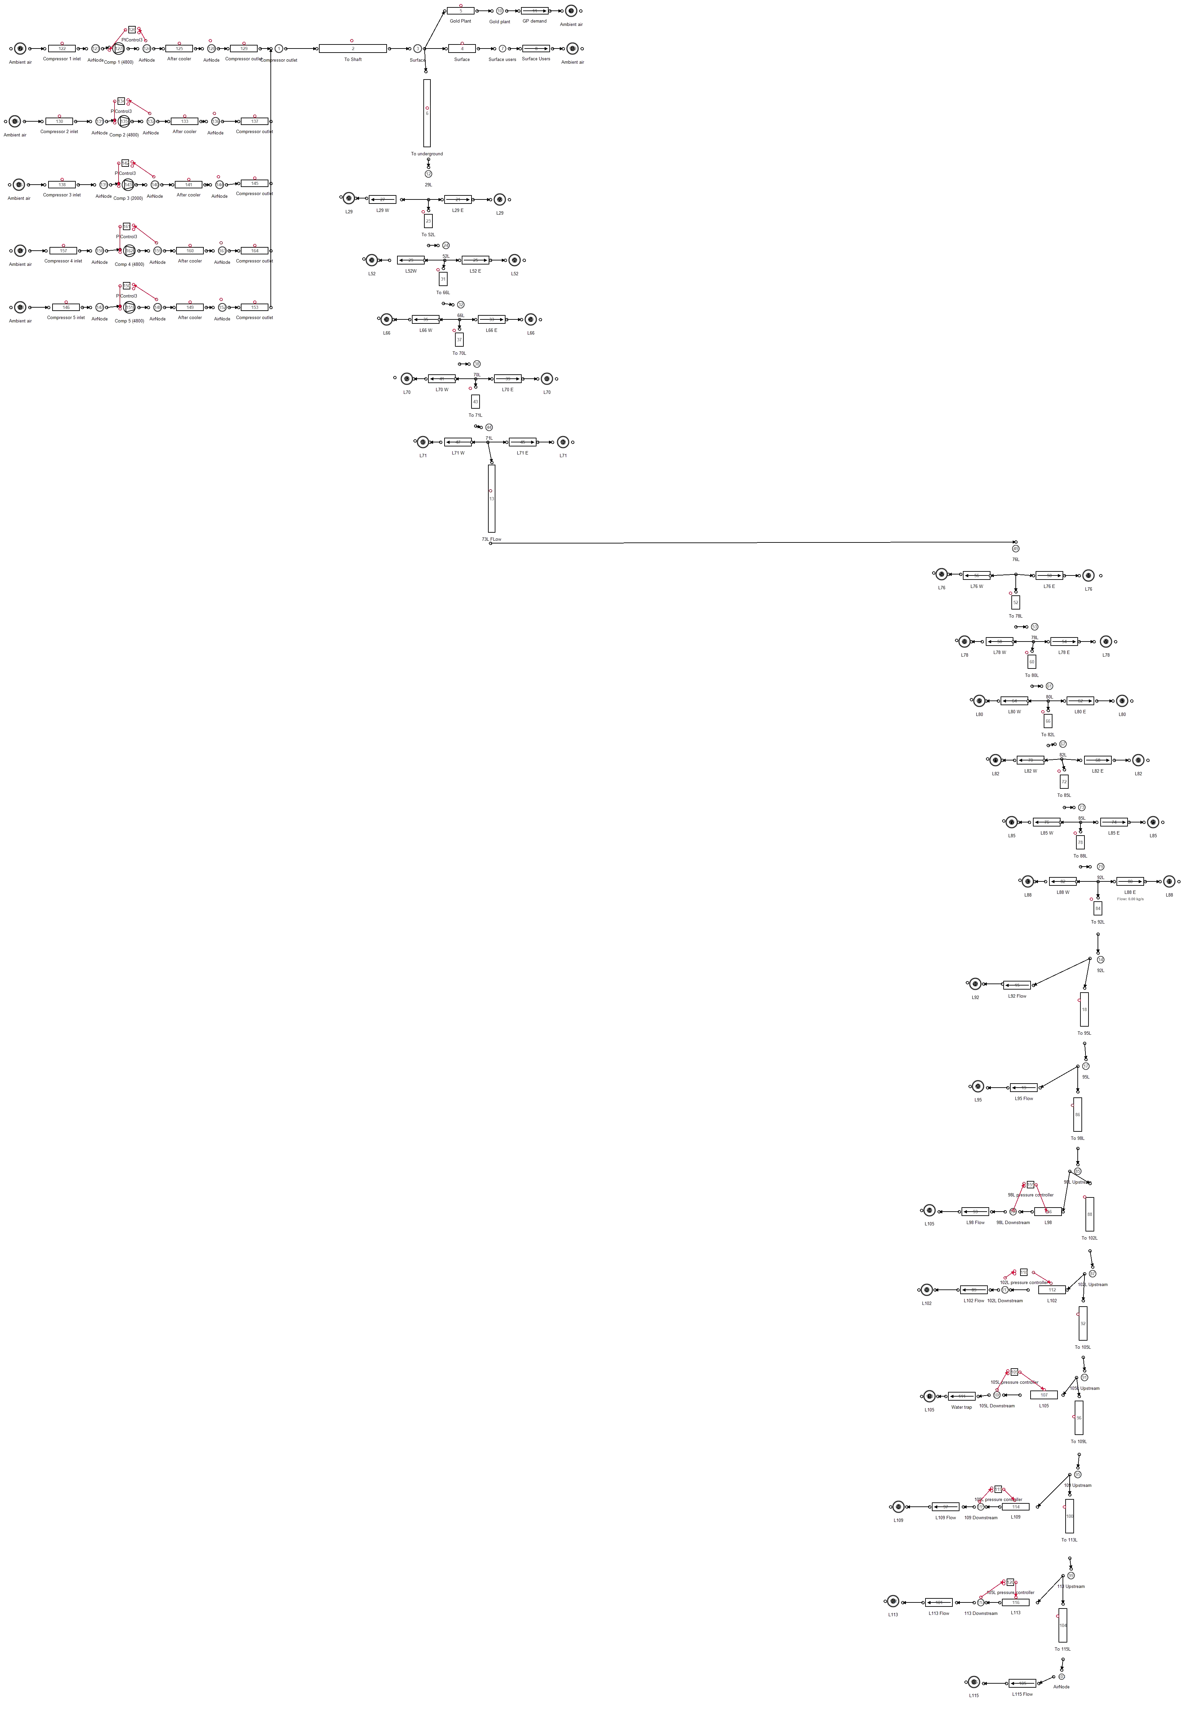

Surfaceusers Se fig.I.4

Mainshaft Se fig.I.5

Compresors Se fig.I.3

Subshaft Se fig.I.6

Figure I.2: Mine B: Baseline process flow schematic

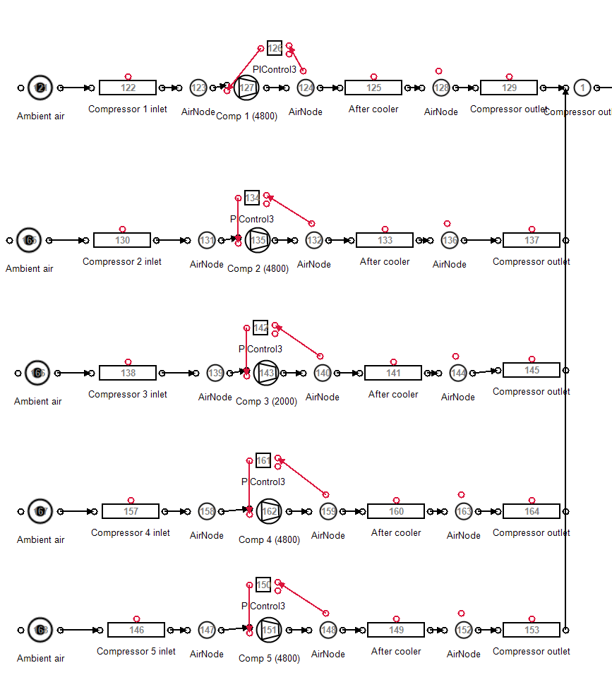

Figure I.3: Mine B: Compressors

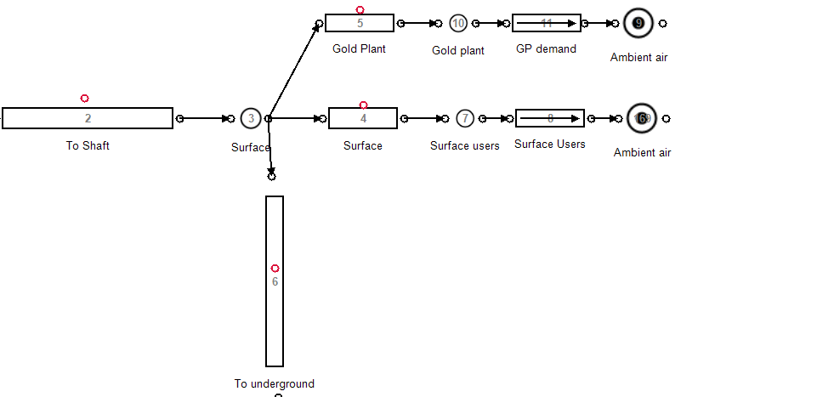

Figure I.4: Mine B: surface compressed air users

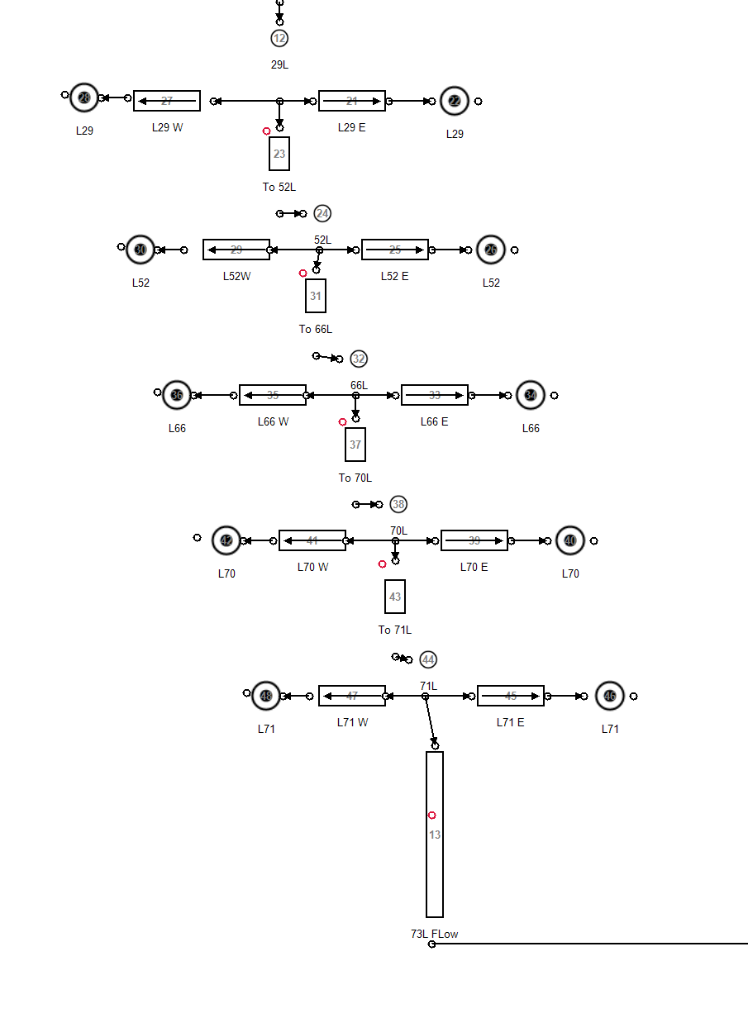

Figure I.5: Mine B: Main shaft compressed air users

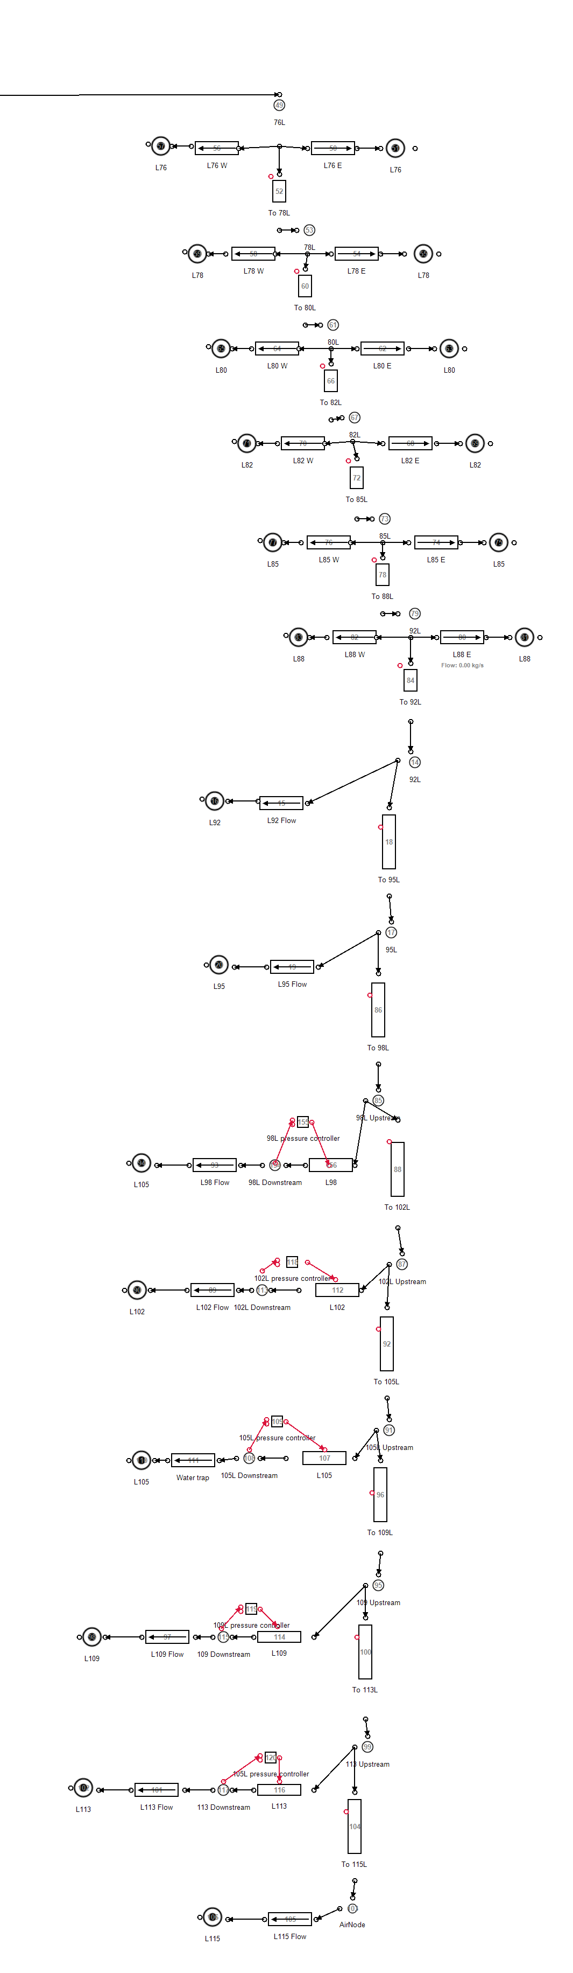

Figure I.6: Mine B: Sub-shaft compressed air users

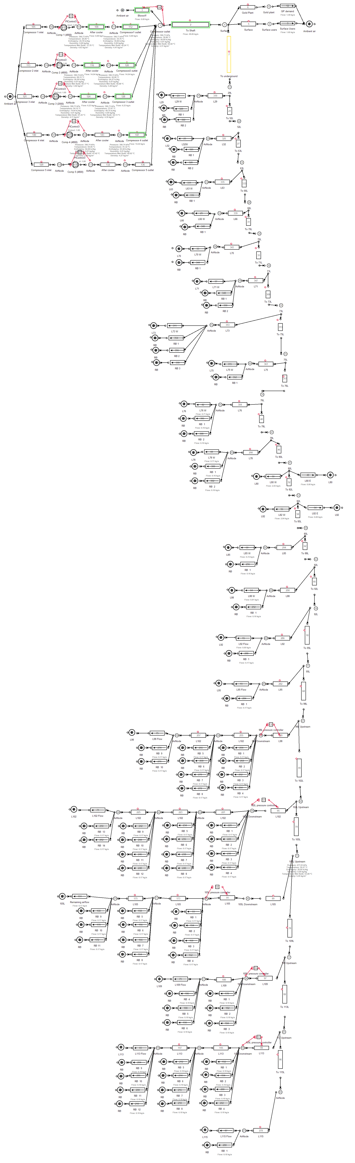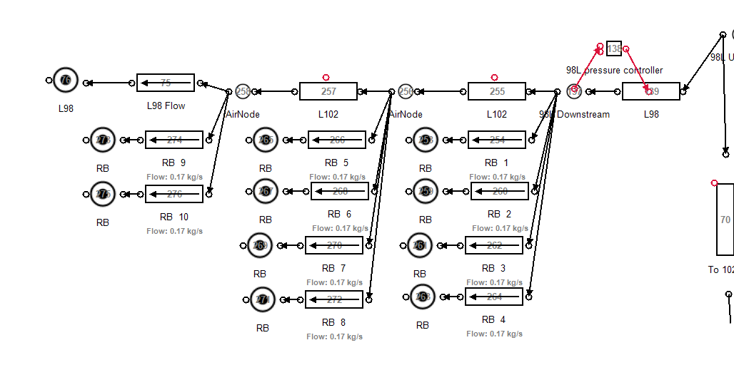

Figure I.7: Mine B: Simulation process Flow diagrams for the refuge bay scenario.

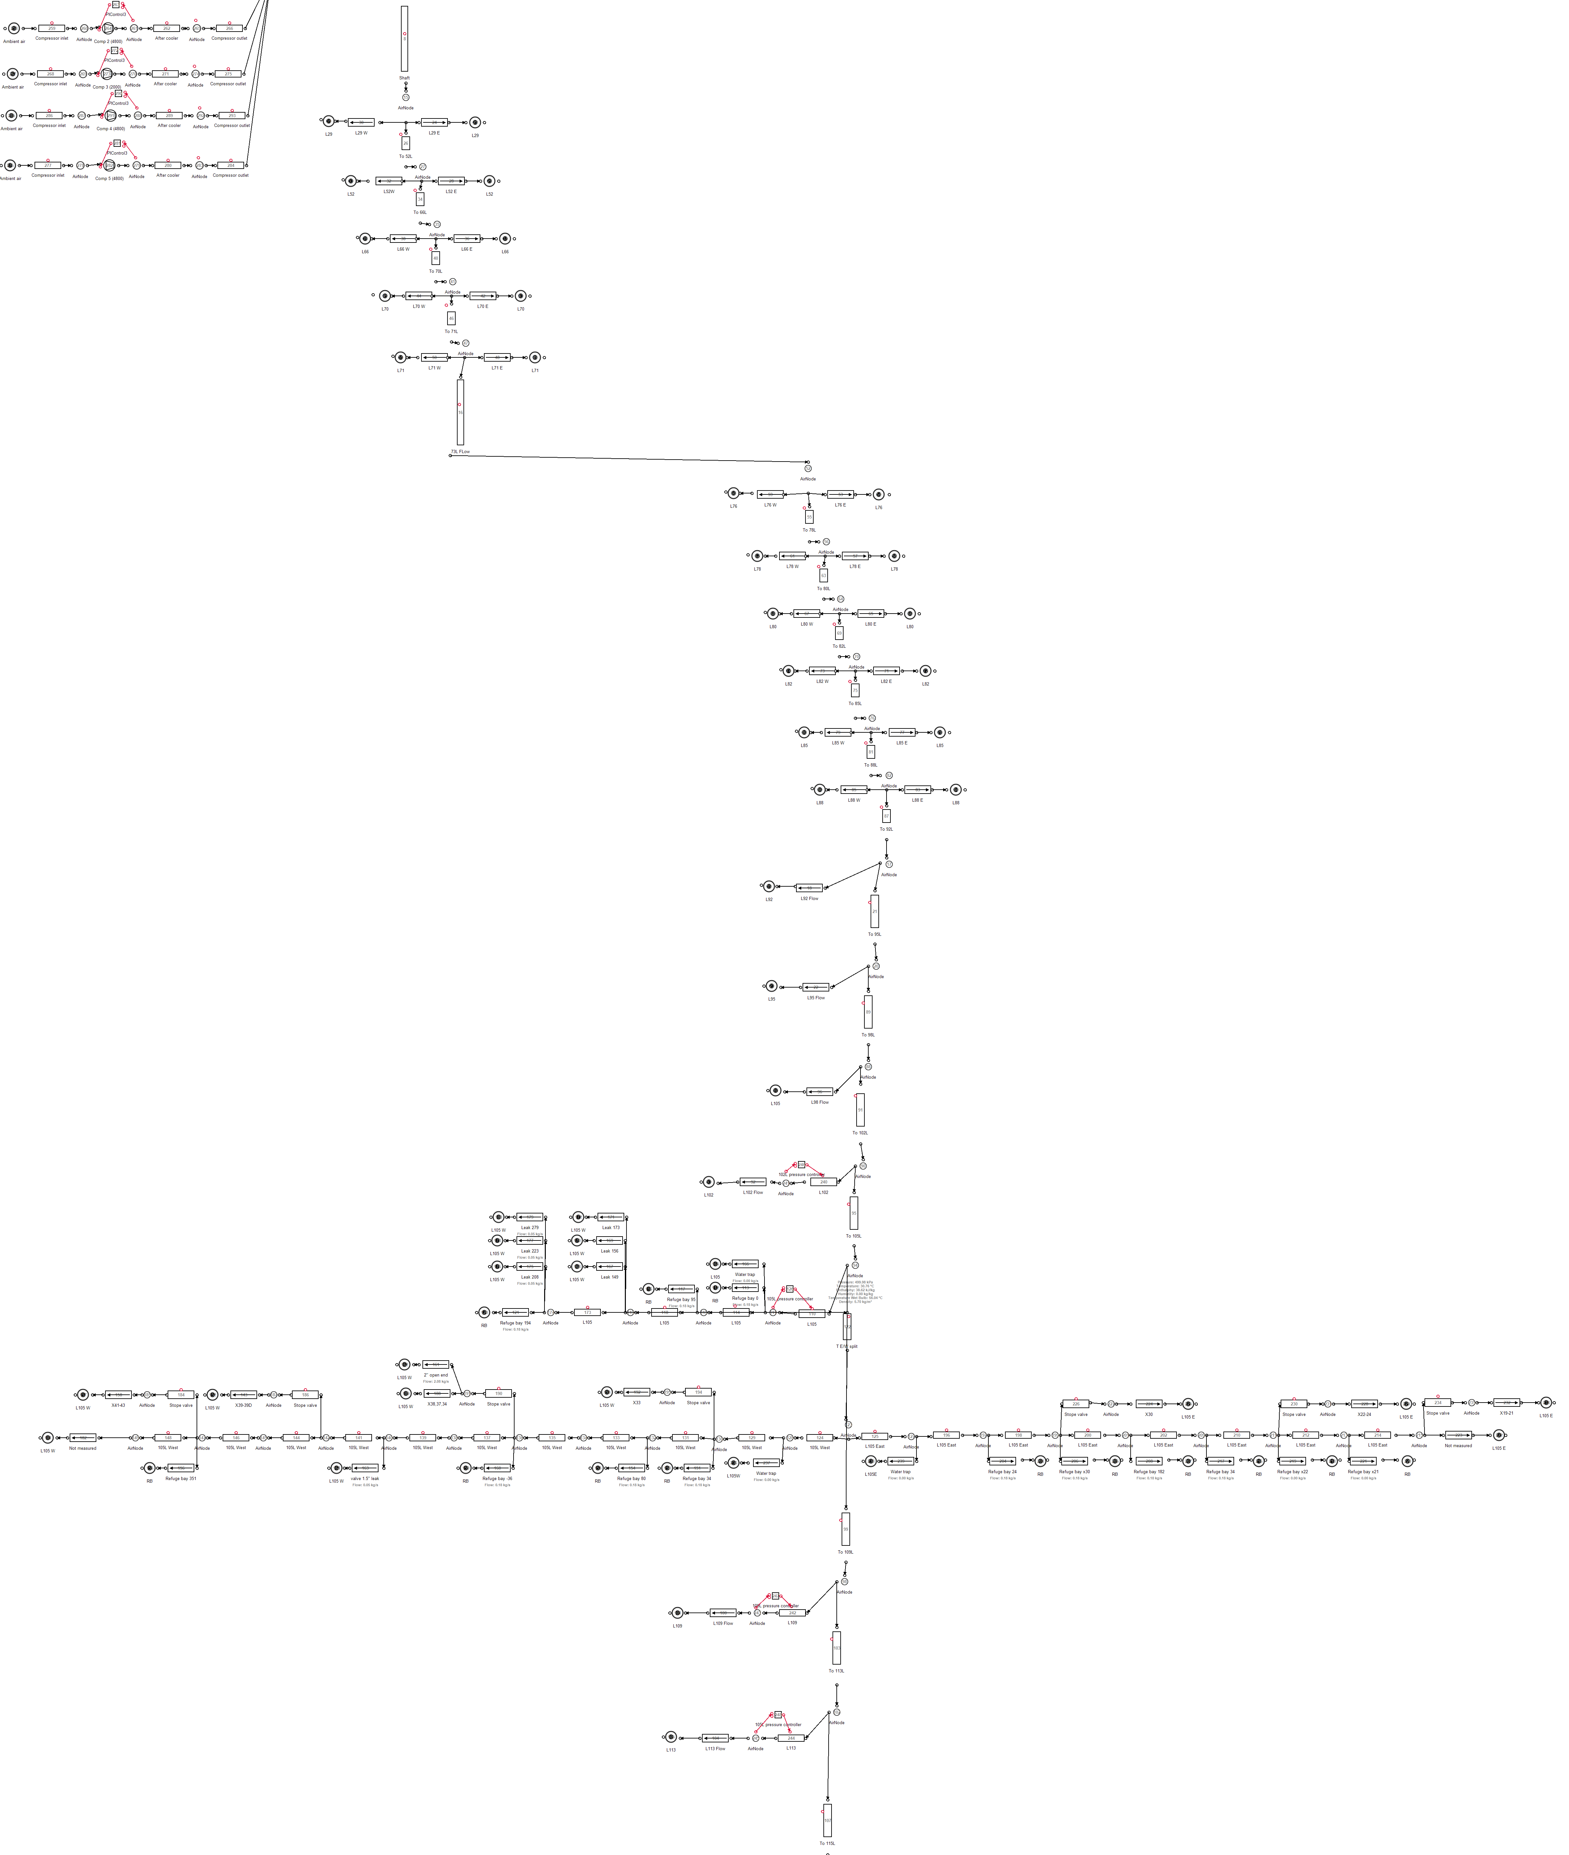

Figure I.8: Mine B: Simulation process Flow diagram for the station isolation stope control.

## APPENDIX II

**Model components verification tables**

Component Actual Ave. Simulated Ave. Accuracy

Power (*kW* )

|  |  |  |  |
| --- | --- | --- | --- |
| VK-32 1 | 0 | 0 | 100% |
| VK-32 2 | 460 | 477 | 96*.*35% |
| VK-32 3 | 142 | 117 | 82*.*31% |
| VK-32 4 | 428 | 408 | 95*.*45% |
| VK-32 5 | 1813 | 1903 | 95*.*03% |
| VK-32 6 | 732 | 725 | 99*.*01% |
| VK-10 1 | 744 | 745 | 90*.*02% |
| VK-10 2 | 687 | 635 | 92*.*24% |
| System | 4940 | 4911 | 97*.*34% |

Flow (*kg/s*)

|  |  |  |  |
| --- | --- | --- | --- |
| 1# 15L | 1*.*45 | 1*.*42 | 97*.*87% |
| 1# 16L | 2*.*15 | 2*.*18 | 98*.*48% |
| 1# 17L | 0*.*34 | 0*.*35 | 97*.*30% |
| 1# 18L | 0*.*38 | 0*.*39 | 97*.*39% |
| 1# 19L | 0*.*31 | 0*.*31 | 98*.*77% |
| 1# 20L | 0*.*12 | 0*.*13 | 92*.*65% |
| 2# 23L | 1*.*31 | 1*.*35 | 96*.*69% |
| 3# 21L | 0*.*67 | 0*.*66 | 98*.*68% |
| 3# 22L | 0*.*74 | 0*.*67 | 89*.*54% |
| 3# 23L | 0*.*04 | 0*.*04 | 98*.*72% |
| 3# 24L | 0*.*11 | 0*.*11 | 98*.*76% |
| 3# 25L | 0*.*33 | 0*.*33 | 99*.*95% |
| 3# 26L | 0*.*45 | 0*.*47 | 95*.*07% |
| Gold Plant | 2*.*59 | 2*.*48 | 95*.*72% |
| Total | 9*.*32 | 9*.*51 | 97*.*01% |

Table II.1: Case study A: Model verification

Component Actual Ave. Simulated Ave. Accuracy

Pressure (*kPa*)

|  |  |  |  |
| --- | --- | --- | --- |
| 1# 15L | 394 | 384 | 98*.*55% |
| 1# 16L | 421 | 419 | 99*.*61% |
| 1# 17L | 345 | 344 | 99*.*81% |
| 1# 18L | 336 | 336 | 99*.*99% |
| 1# 19L | 311 | 309 | 99*.*53% |
| 1# 20L | 368 | 368 | 99*.*90% |
| 2# 23L | 365 | 327 | 91*.*25% |
| 3# 21L | 303 | 302 | 99*.*92% |
| 3# 22L | 332 | 301 | 95*.*42% |
| 3# 23L | 332 | 332 | 99*.*98% |
| 3# 24L | 413 | 409 | 99*.*10% |
| 3# 25L | 413 | 409 | 99*.*01% |
| 3# 26L | 515 | 509 | 98*.*99% |
| Surface | 502 | 501 | 99*.*95% |

Table II.2: Case study A: Model verification continued

Component Actual Ave. Simulated Ave. Accuracy

Power (*kW* )

|  |  |  |  |
| --- | --- | --- | --- |
| Compressor 1 | 3406 | 3669 | 92*.*37% |
| Compressor 2 | 3911 | 3668 | 93*.*92% |
| Compressor 3 | 1440 | 1453 | 99*.*05% |
| Compressor 4 | 0 | 0 | 100% |
| Compressor 5 | 3299 | 3274 | 99*.*22% |
| System | 12057 | 12103 | 98*.*73% |

Flow (*kg/s*)

|  |  |  |  |
| --- | --- | --- | --- |
| 95L | 1*.*51 | 1*.*42 | 93*.*95% |
| 98L | 3*.*75 | 3*.*53 | 93*.*99% |
| 102L | 2*.*97 | 2*.*79 | 98*.*72% |
| 105L | 5*.*65 | 5*.*71 | 98*.*84% |
| 109L | 3*.*57 | 3*.*37 | 94*.*27% |
| 113L | 5*.*09 | 4*.*84 | 95*.*05% |
| Gold Plant | 1*.*41 | 1*.*35 | 95*.*14% |
| Sub-shaft total | 34*.*12 | 34*.*76 | 98*.*09% |
| Total | 41*.*65 | 41*.*43 | 98*.*96% |

Pressure (*kPa*)

Surface 393 396 99*.*02%

Table II.3: Case study B: Model verification

**APPENDIX III**

## Detailed mining level investigation diagrams

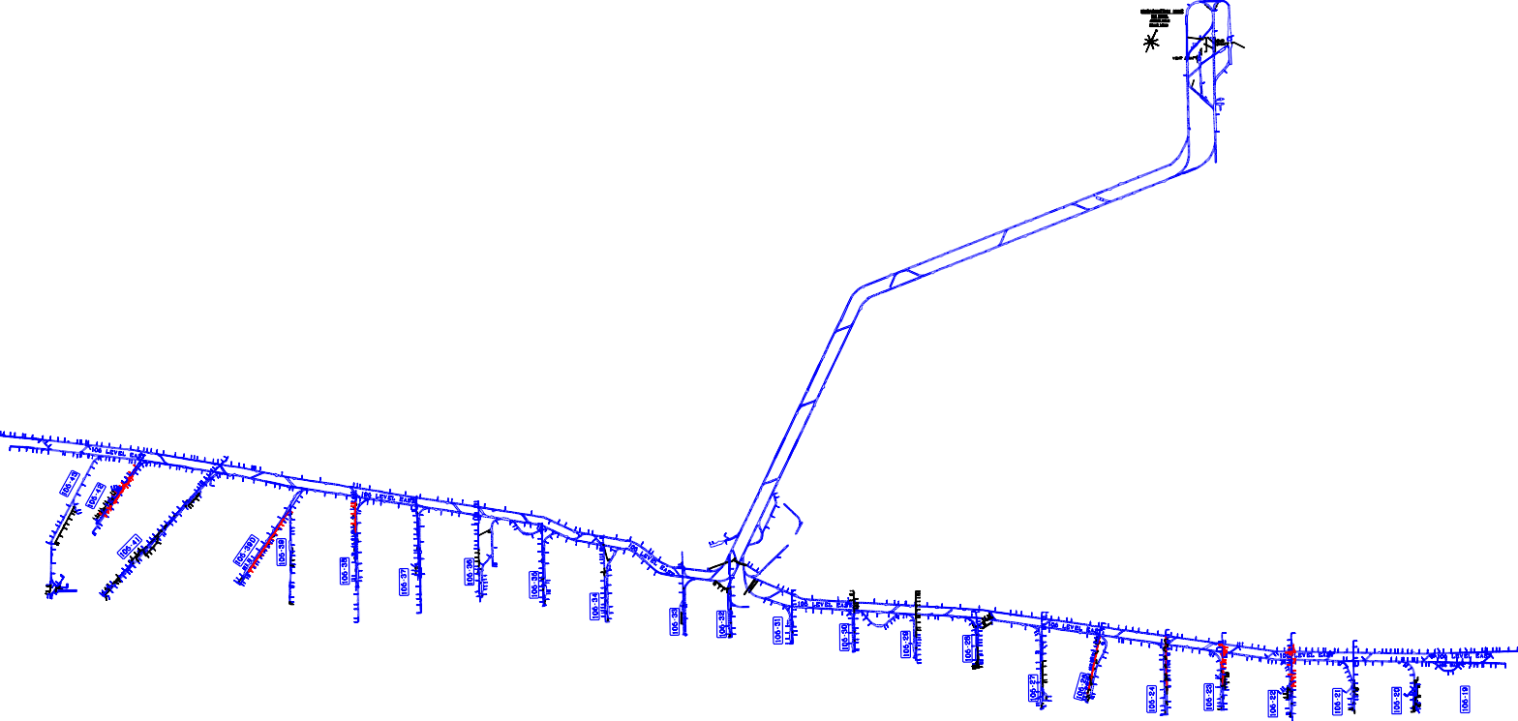

Appendix III.

Detailed mining level investigation diagrams

Figure III.1: Underground mining level layout.

*Simulating improvements on mining compressed air systems*

98